|  |  |  |
| --- | --- | --- |
| **2018/6/26** | **603045** | **福达合金** |

次新股新低

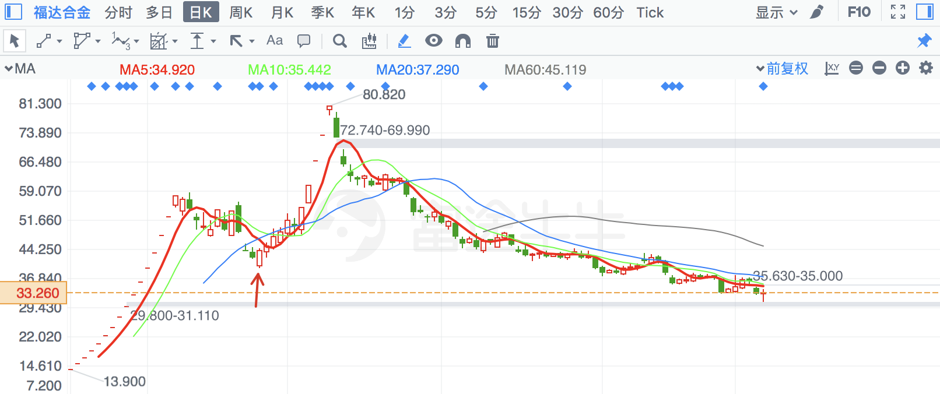

|  |  |  |
| --- | --- | --- |
| **2018/7/6** | **2256** | **兆新股份** |

金针探底

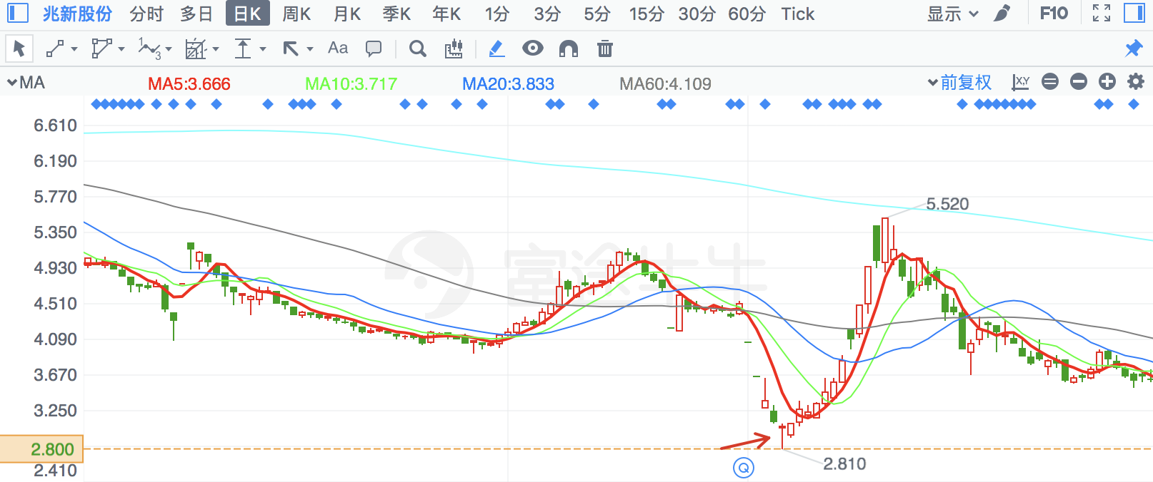

|  |  |  |
| --- | --- | --- |
| **2018/6/25** | **300745** | **欣锐科技** |

次新股新低

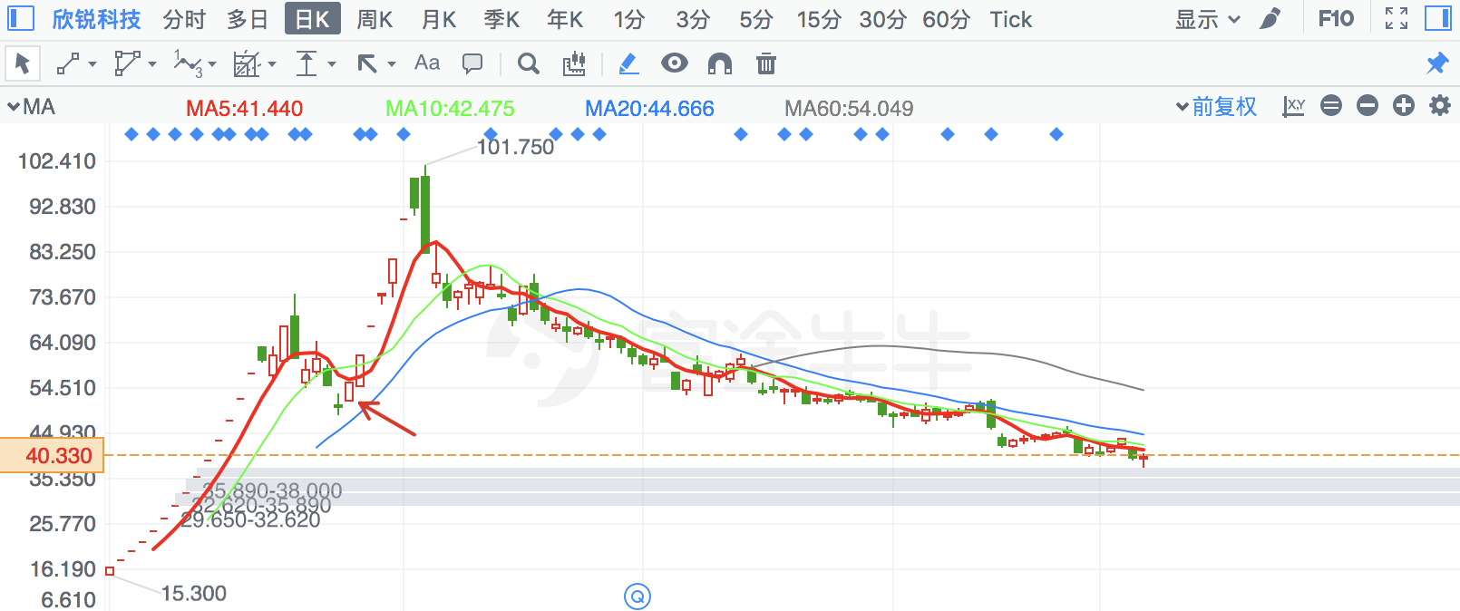

|  |  |  |
| --- | --- | --- |
| **2018/6/22** | **300139** | **晓程科技** |

同时有年线和月线支撑，倒锤子线

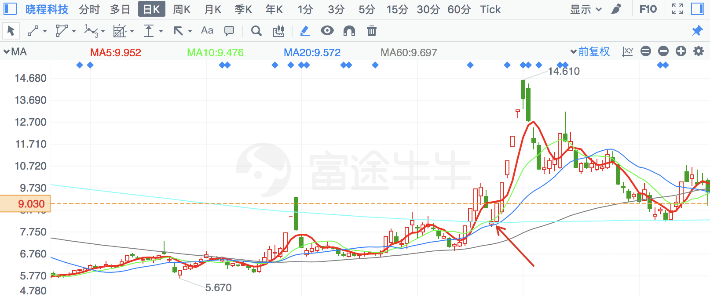

|  |  |  |
| --- | --- | --- |
| **2018/3/26** | **613** | **大东海A** |

有季线支撑

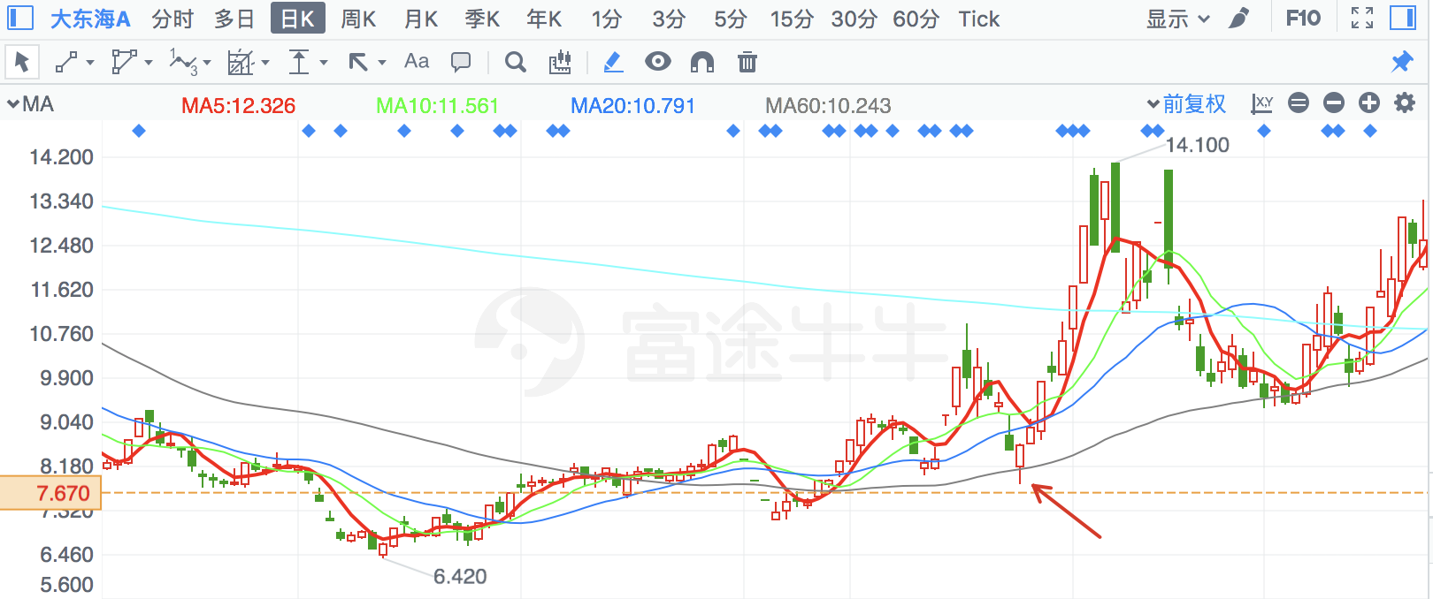

|  |  |  |
| --- | --- | --- |
| **2018/2/9** | **2320** | **海峡股份** |

有年线支撑

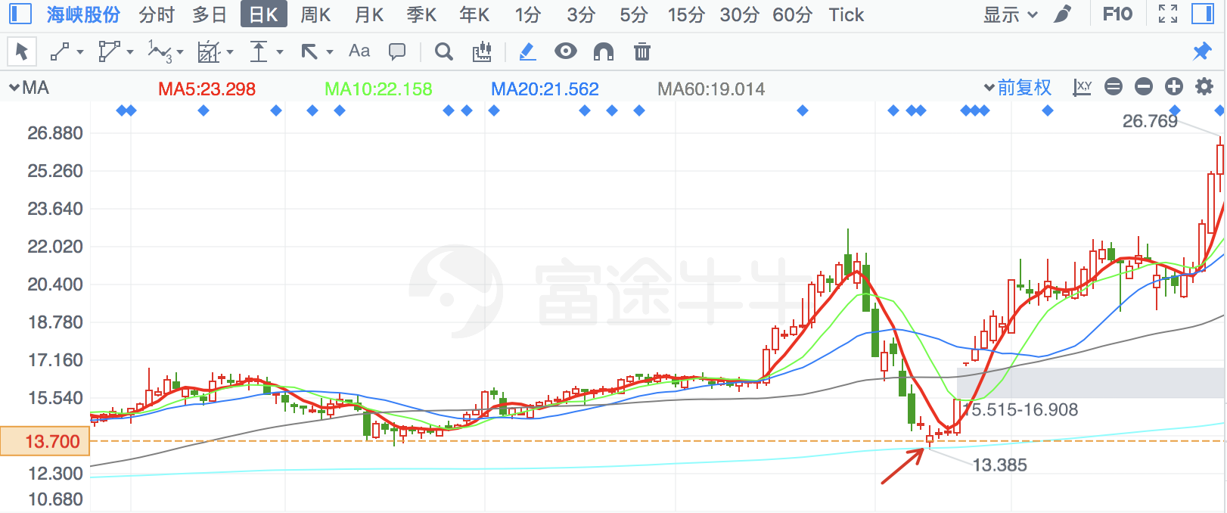

|  |  |  |
| --- | --- | --- |
| **2018/7/9** | **600532** | **宏达矿业** |

倒锤子线

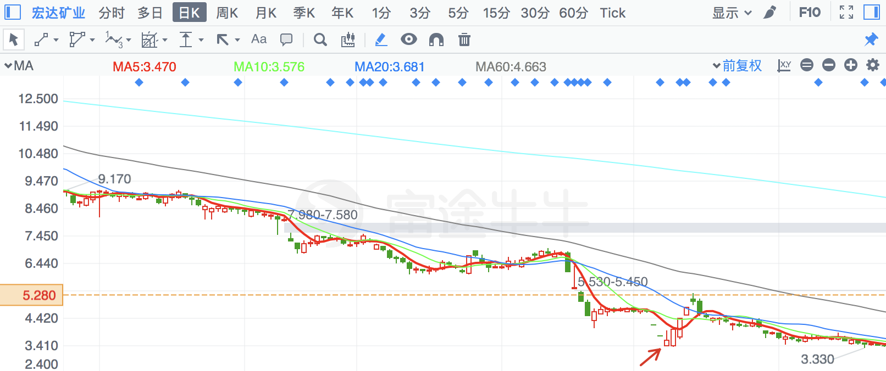

|  |  |  |
| --- | --- | --- |
| **2018/2/5** | **2925** | **盈趣科技** |

次新股新低，倒锤子线

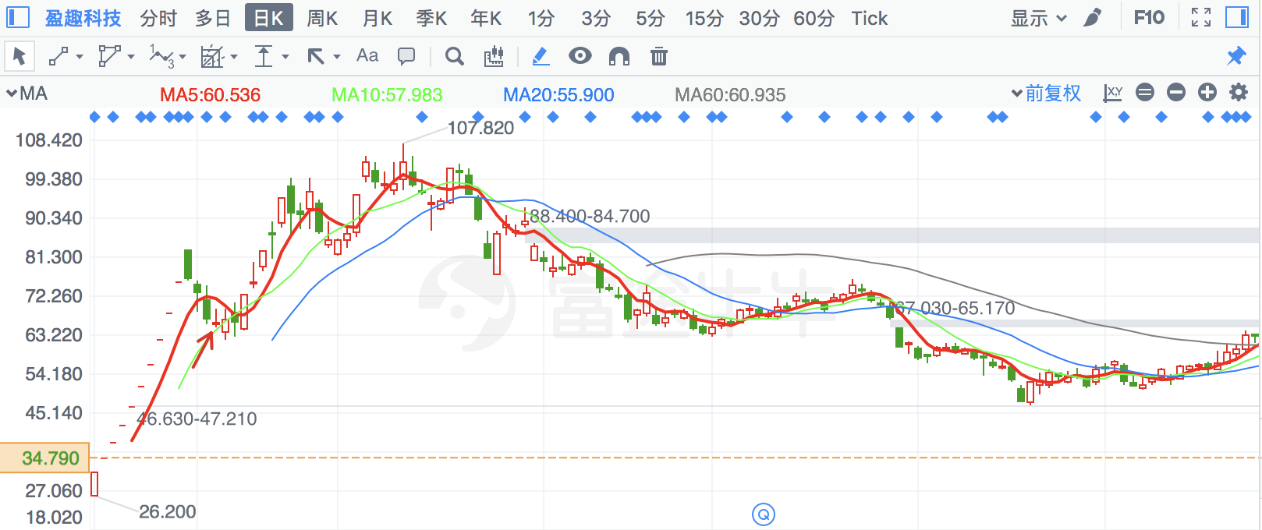

|  |  |  |
| --- | --- | --- |
| **2018/5/3** | **2877** | **智能自控** |

下有很多缺口及季线

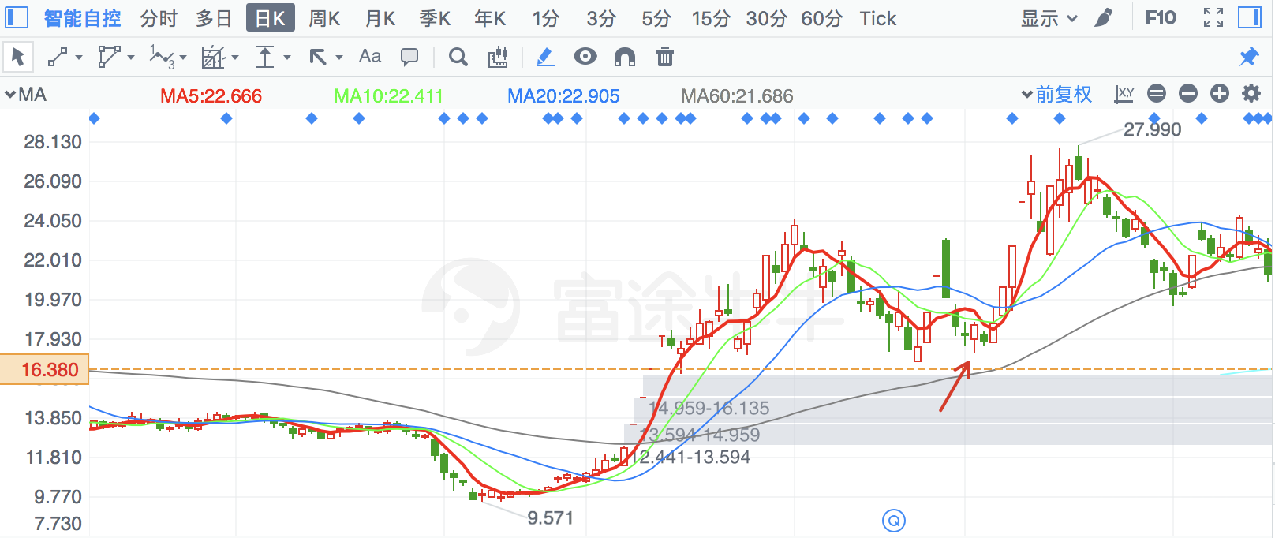

|  |  |  |
| --- | --- | --- |
| **2018/3/26** | **300412** | **迦南科技** |

前期底部支撑

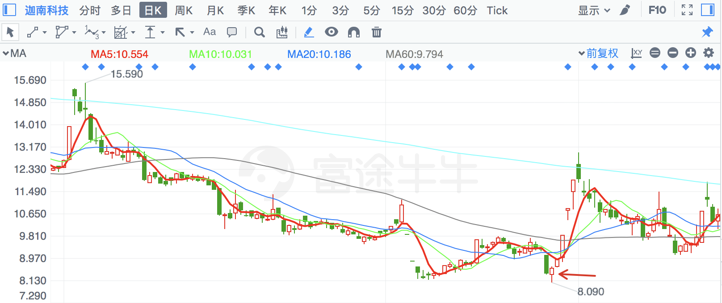

|  |  |  |
| --- | --- | --- |
| **2018/6/22** | **868** | **安凯客车** |

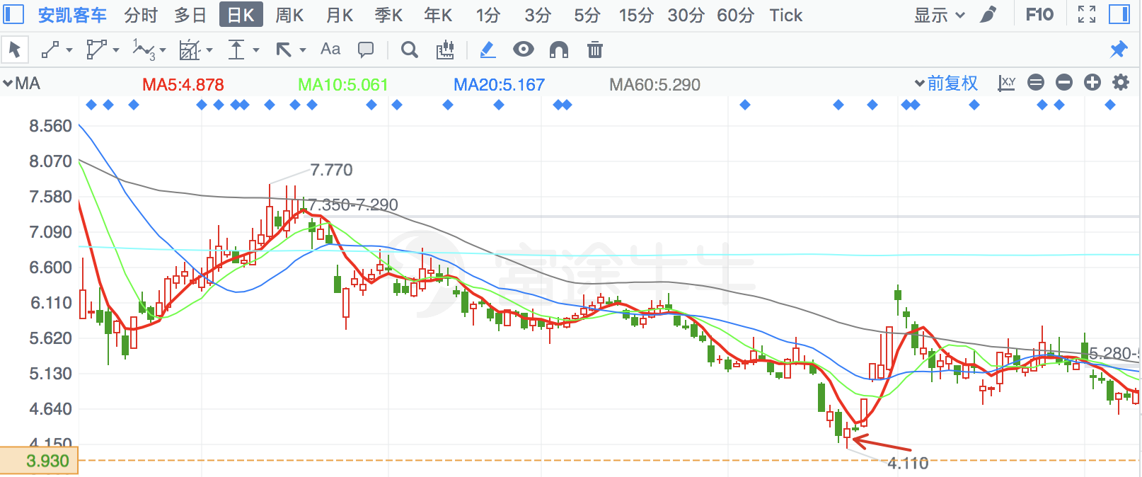

|  |  |  |
| --- | --- | --- |
| **2018/3/26** | **300701** | **森霸传感** |

同时有月线、季线支撑

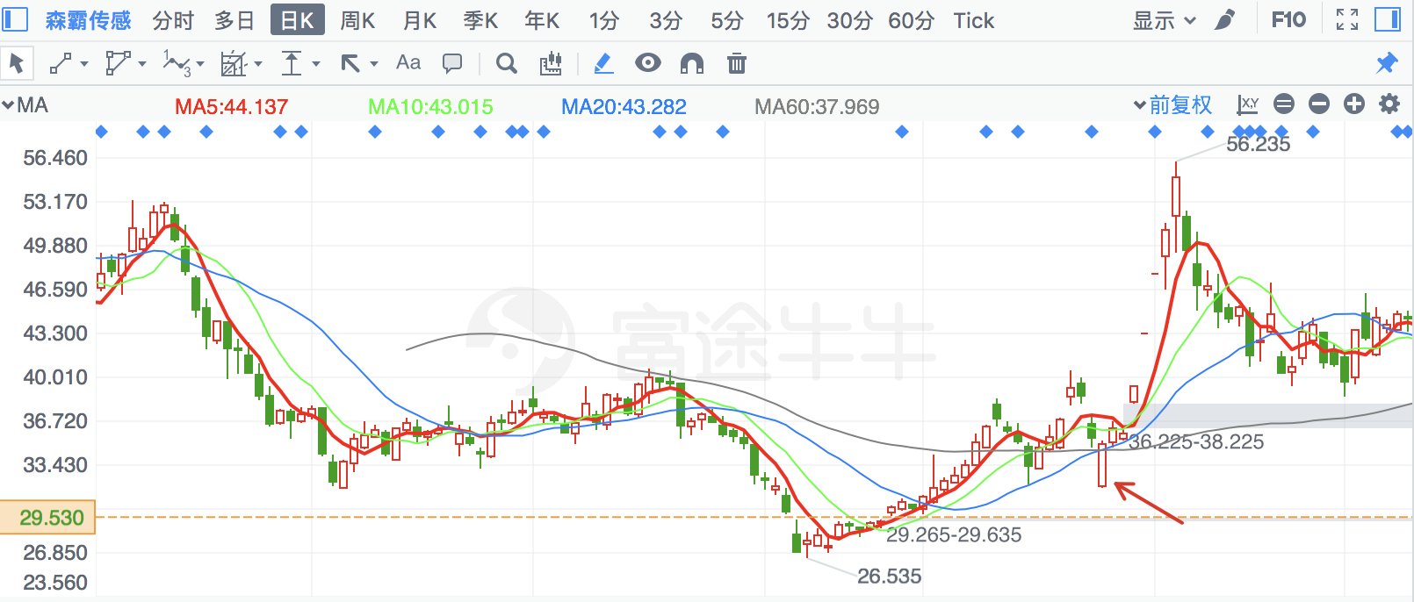

|  |  |  |
| --- | --- | --- |
| **2018/3/26** | **603918** | **金桥信息** |

金针探底，有前期底部支撑

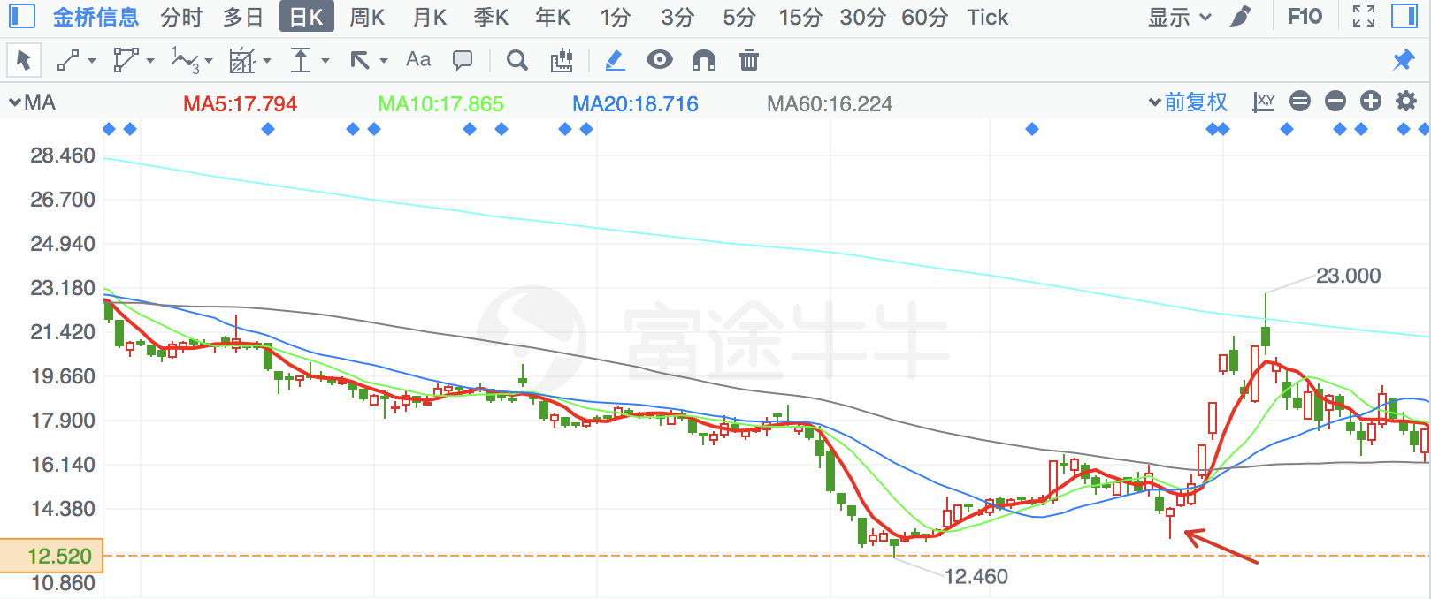

|  |  |  |
| --- | --- | --- |
| **2018/2/7** | **603895** | **天永智能** |

次新股新低

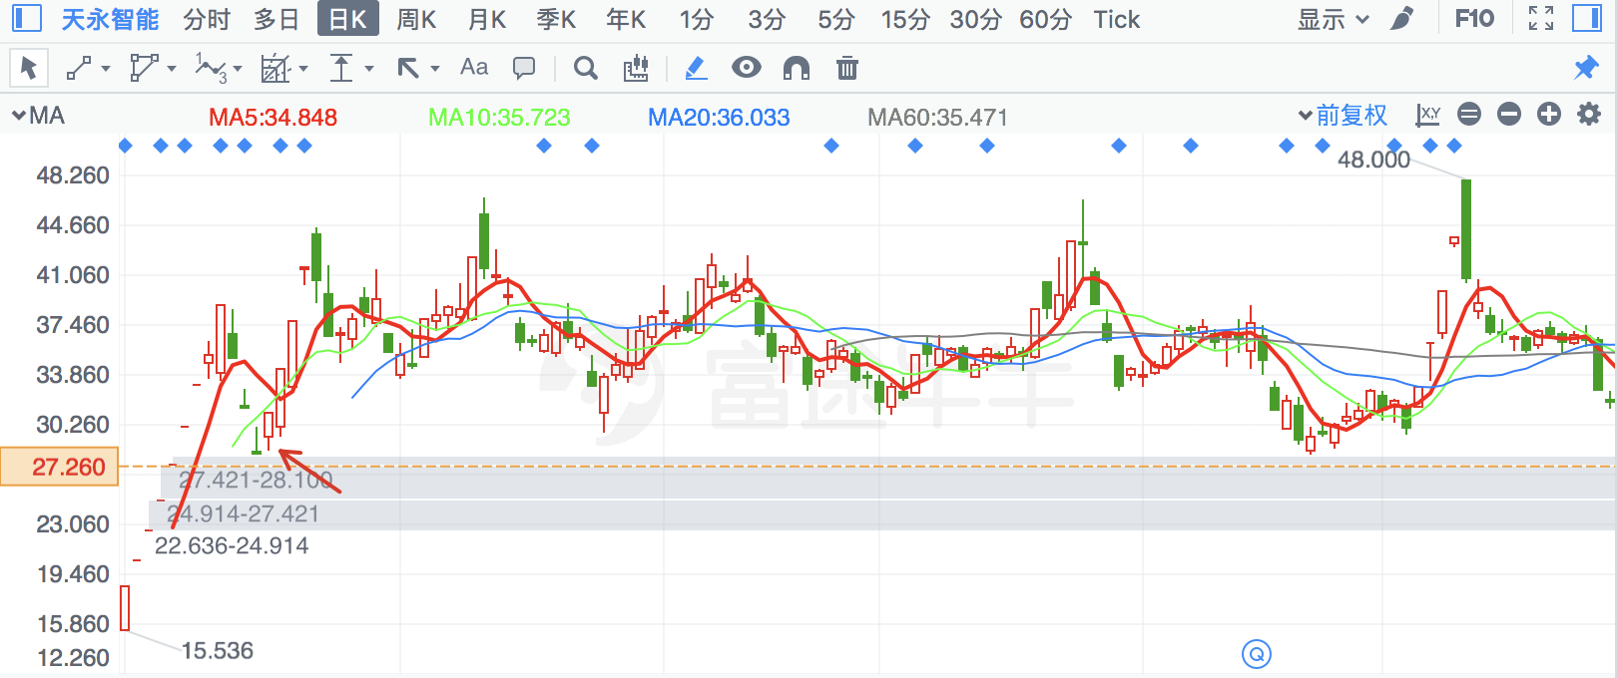

|  |  |  |
| --- | --- | --- |
| **2018/2/7** | **300170** | **汉得信息** |

金针探底，前有前期底部支撑，有年线支撑

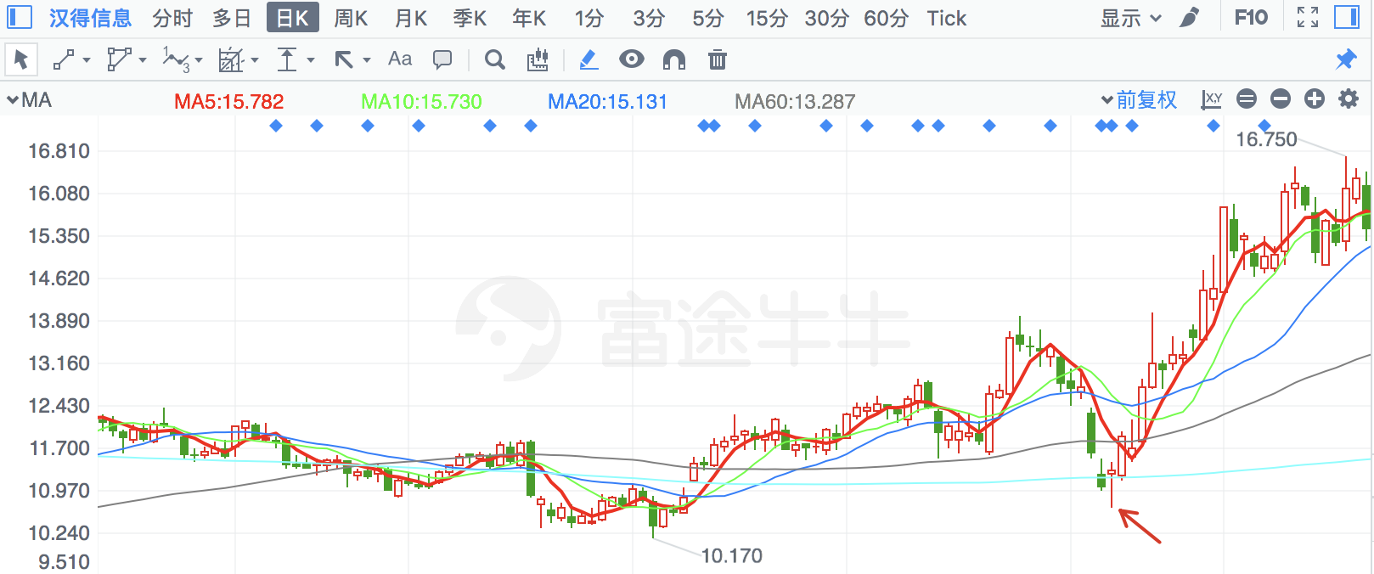

|  |  |  |
| --- | --- | --- |
| **2018/2/7** | **600610** | **\*ST毅达** |

倒锤子线

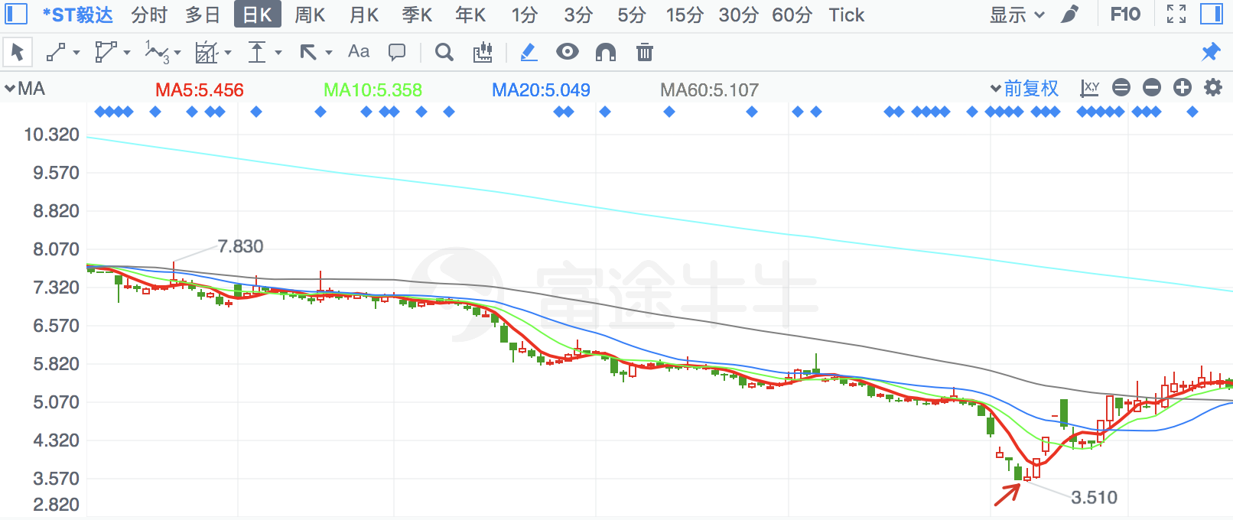

|  |  |  |
| --- | --- | --- |
| **2018/7/10** | **600532** | **宏达矿业** |

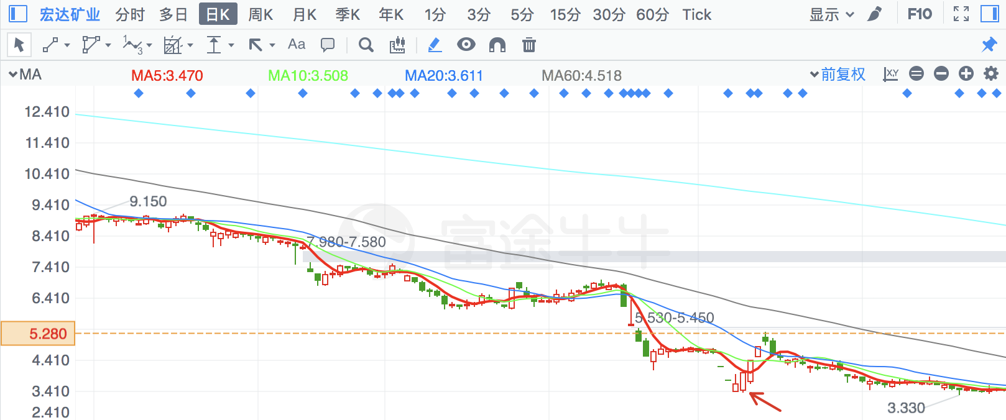

|  |  |  |
| --- | --- | --- |
| **2018/3/26** | **300493** | **润欣科技** |

金针探底，前有前期底部支撑

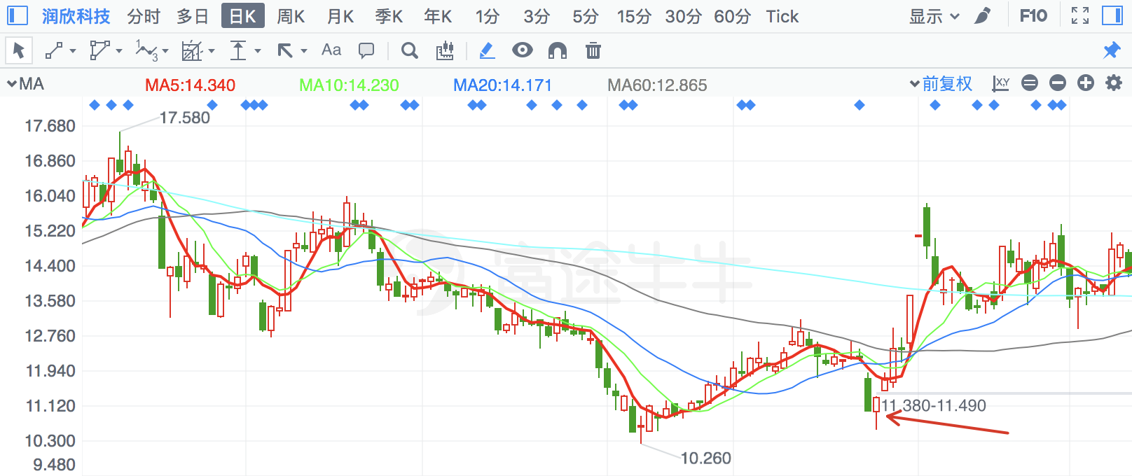

|  |  |  |
| --- | --- | --- |
| **2018/3/26** | **300648** | **星云股份** |

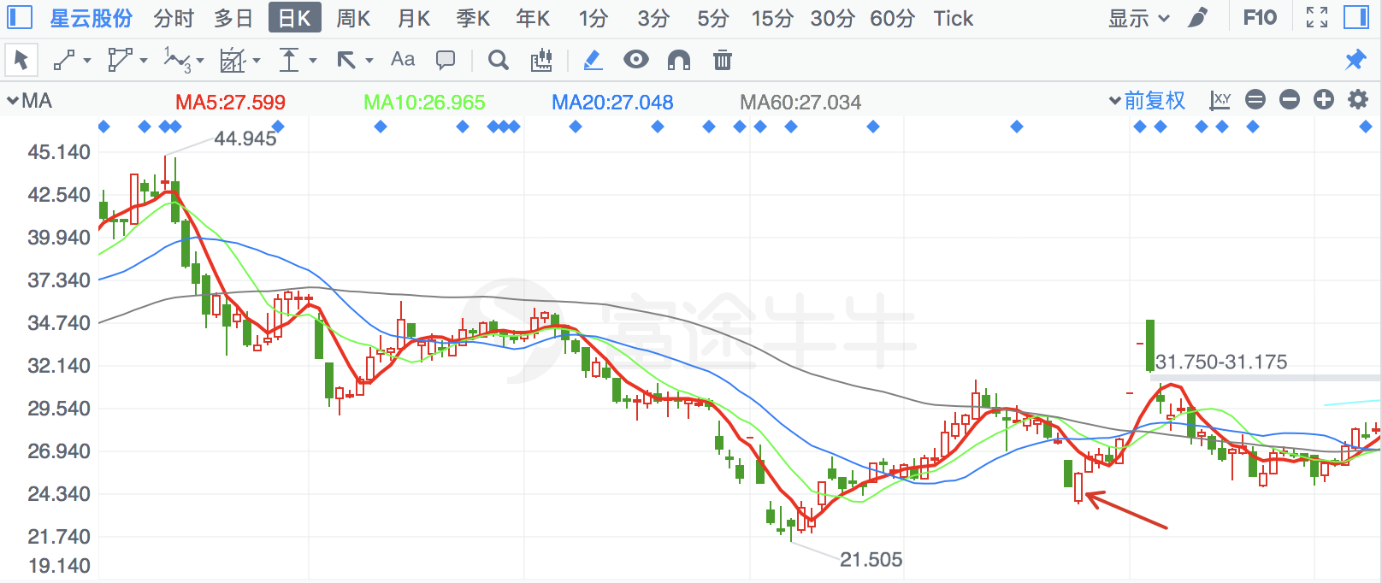

|  |  |  |
| --- | --- | --- |
| **2018/3/26** | **300507** | **苏奥传感** |

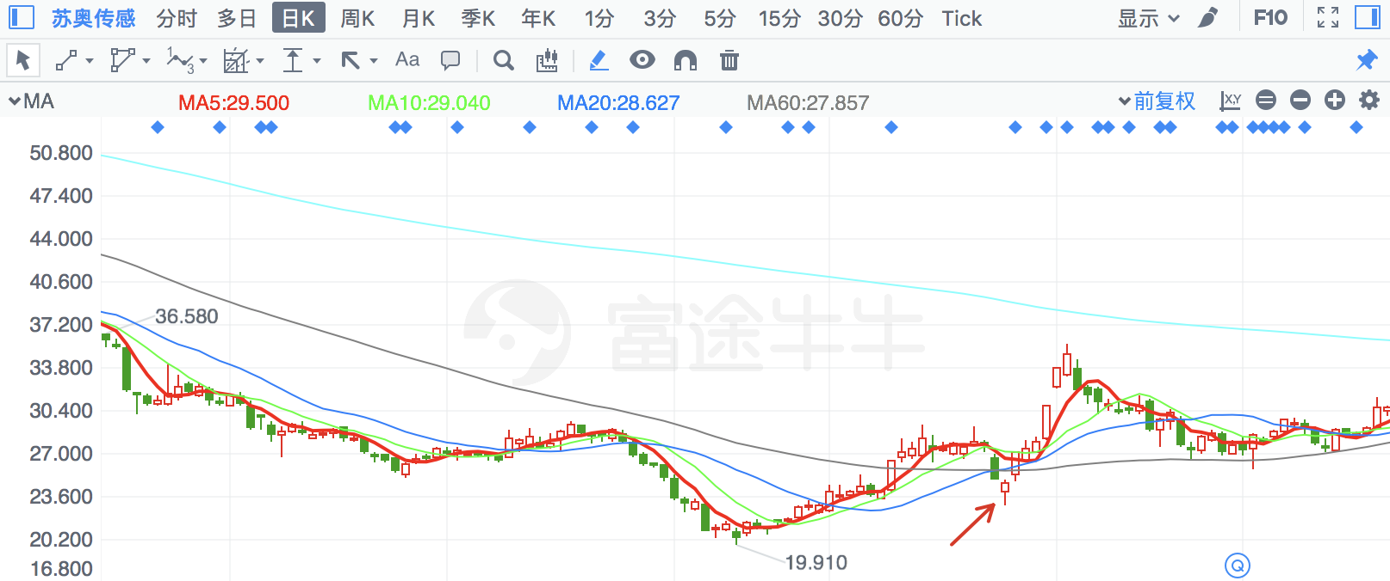

|  |  |  |
| --- | --- | --- |
| **2018/3/26** | **300619** | **金银河** |

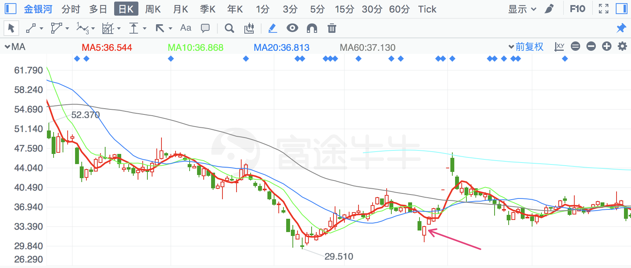

|  |  |  |
| --- | --- | --- |
| **2018/6/20** | **300667** | **必创科技** |

有前期缺口支撑

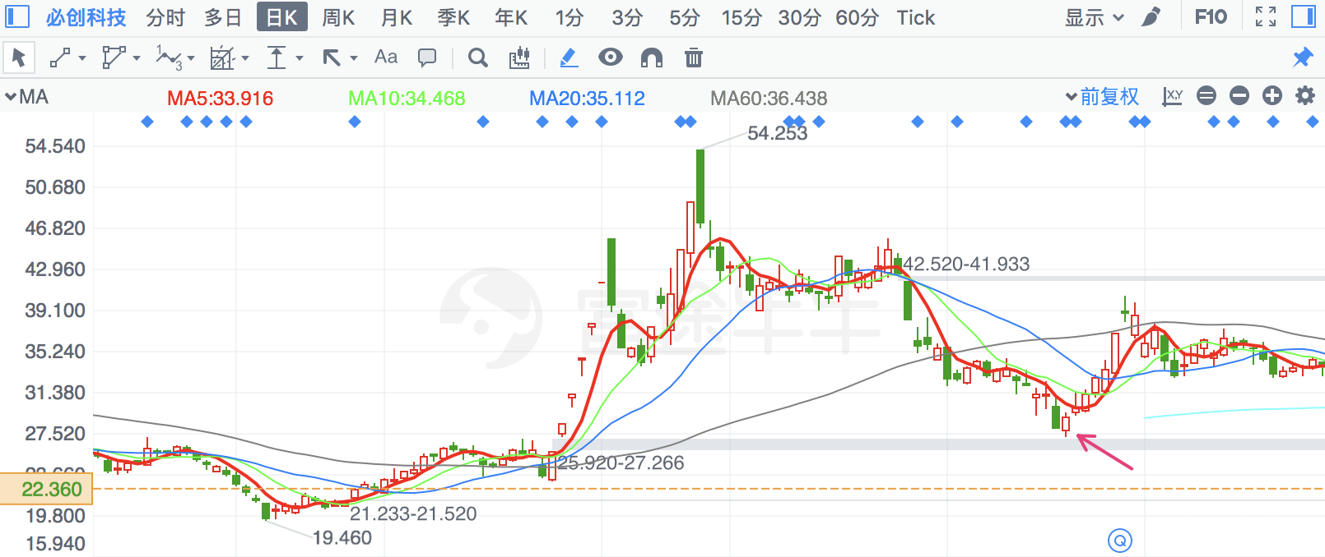

|  |  |  |
| --- | --- | --- |
| **2018/3/26** | **300550** | **和仁科技** |

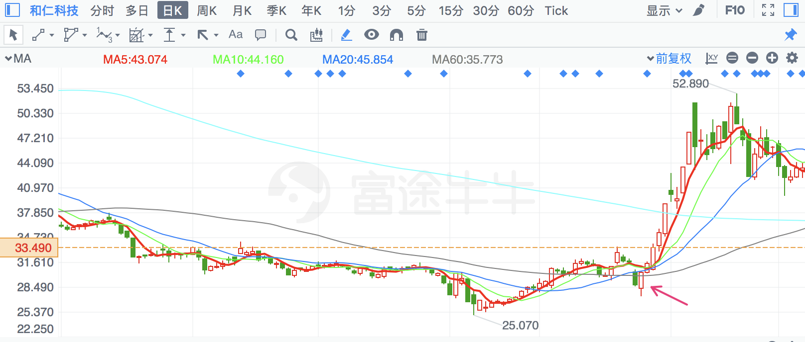

|  |  |  |
| --- | --- | --- |
| **2018/3/26** | **603648** | **畅联股份** |

金针探底

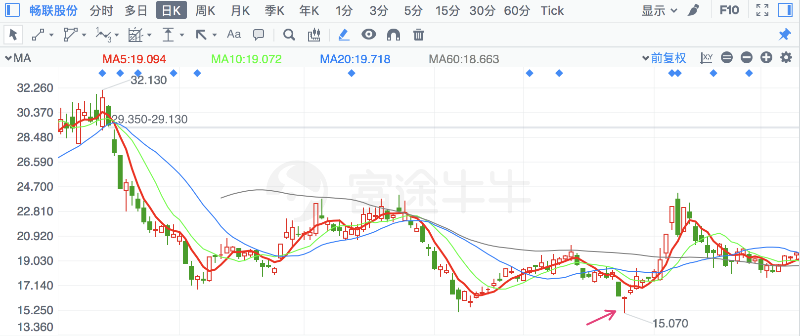

|  |  |  |
| --- | --- | --- |
| **2018/5/31** | **2889** | **东方嘉盛** |

有季线支撑

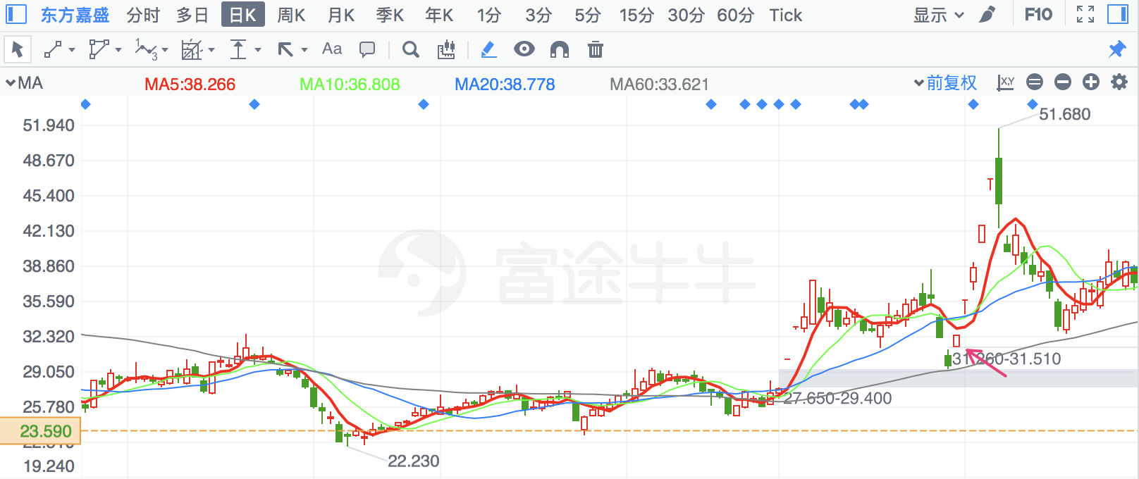

|  |  |  |
| --- | --- | --- |
| **2018/2/6** | **2925** | **盈趣科技** |

次新股新低

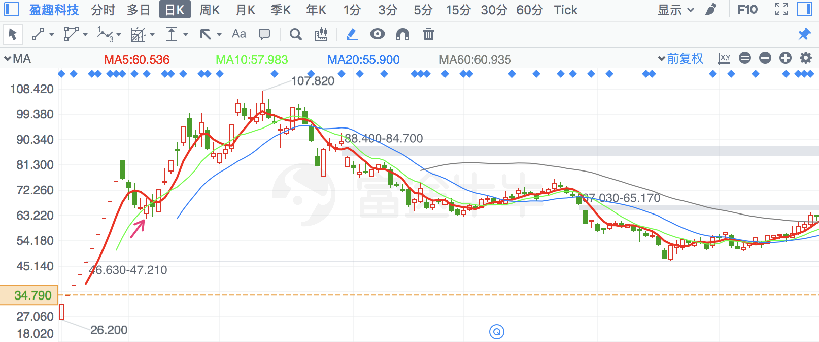

|  |  |  |
| --- | --- | --- |
| **2018/3/26** | **300223** | **北京君正** |

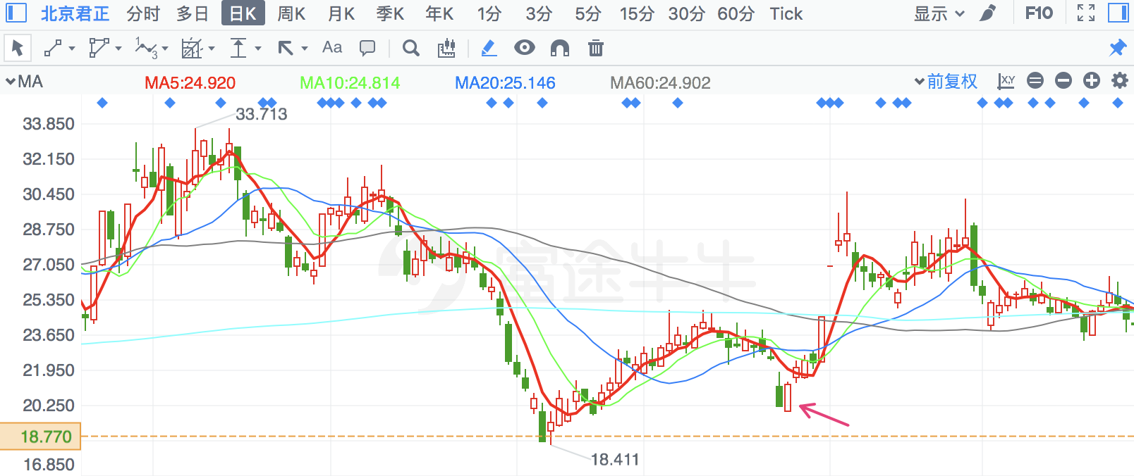

|  |  |  |
| --- | --- | --- |
| **2018/3/26** | **300354** | **东华测试** |

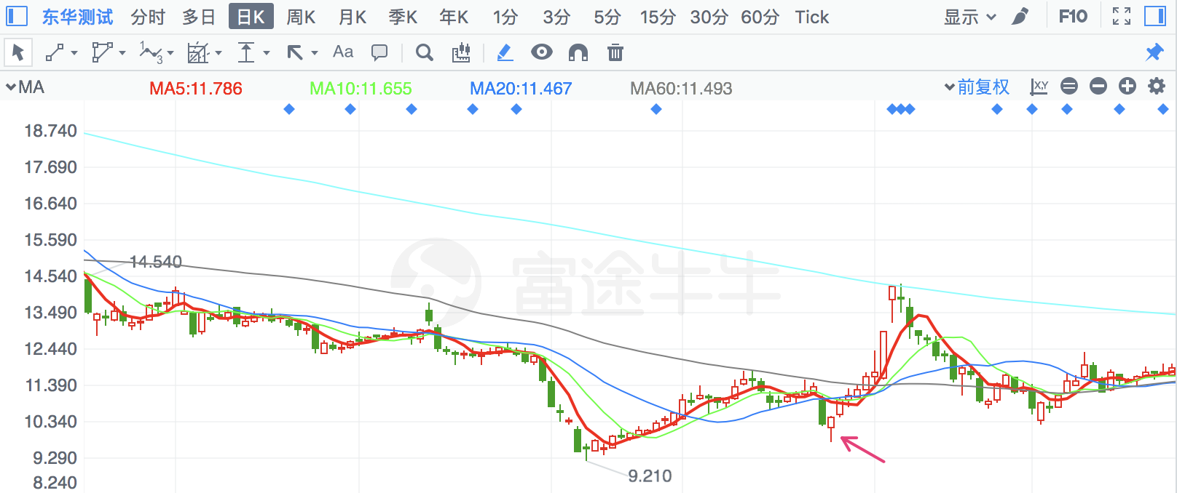

|  |  |  |
| --- | --- | --- |
| **2018/3/26** | **300161** | **华中数控** |

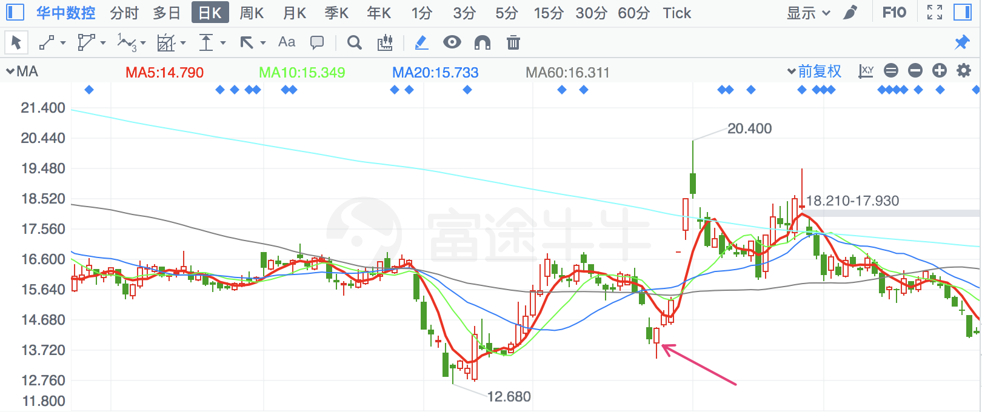

|  |  |  |
| --- | --- | --- |
| **2018/5/3** | **300256** | **星星科技** |

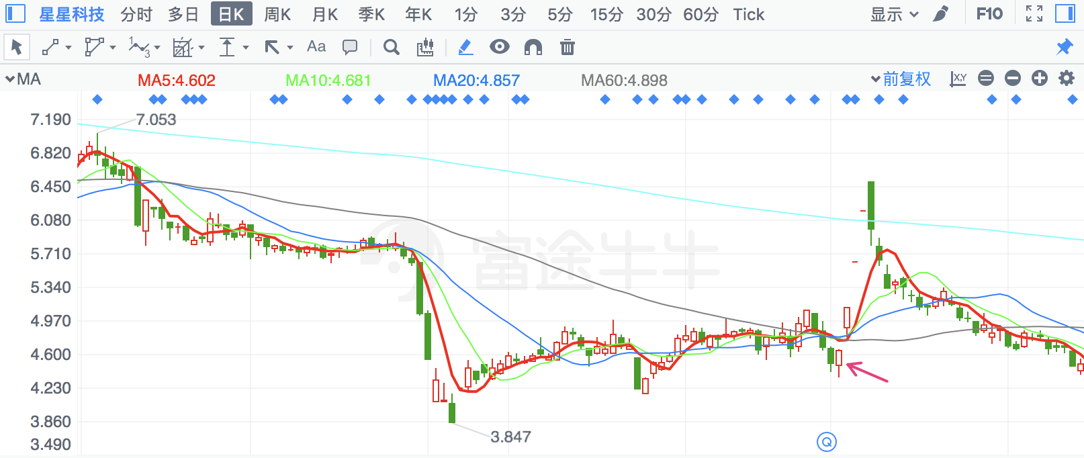

|  |  |  |
| --- | --- | --- |
| **2018/5/25** | **2691** | **冀凯股份** |

倒锤子线

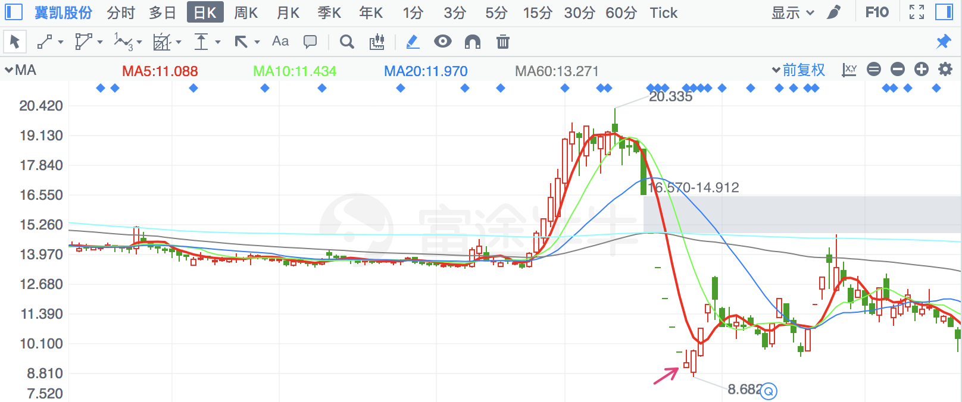

|  |  |  |
| --- | --- | --- |
| **2018/3/26** | **300525** | **博思软件** |

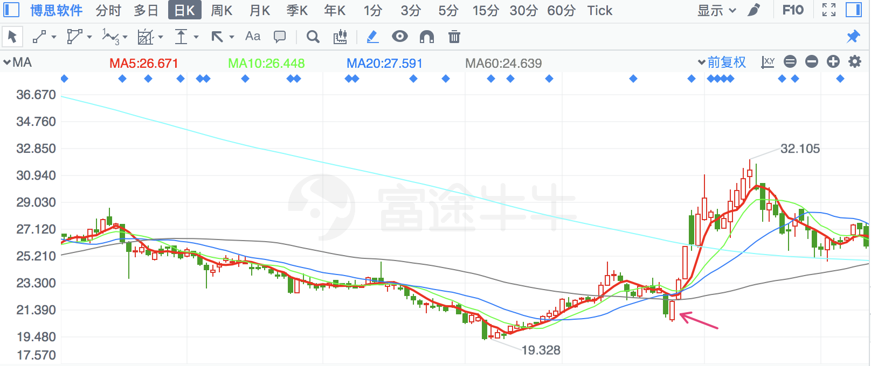

|  |  |  |
| --- | --- | --- |
| **2018/2/12** | **600789** | **鲁抗医药** |

有月线、年线支撑

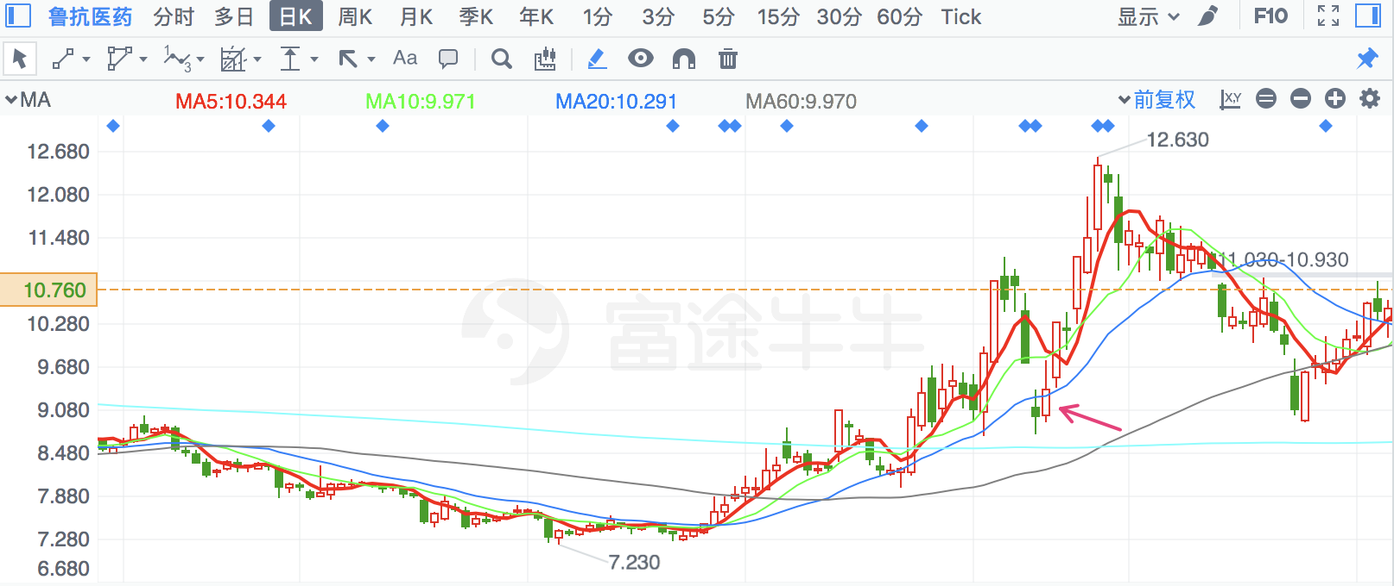

|  |  |  |
| --- | --- | --- |
| **2018/8/2** | **600722** | **金牛化工** |

金针探底，月线支撑

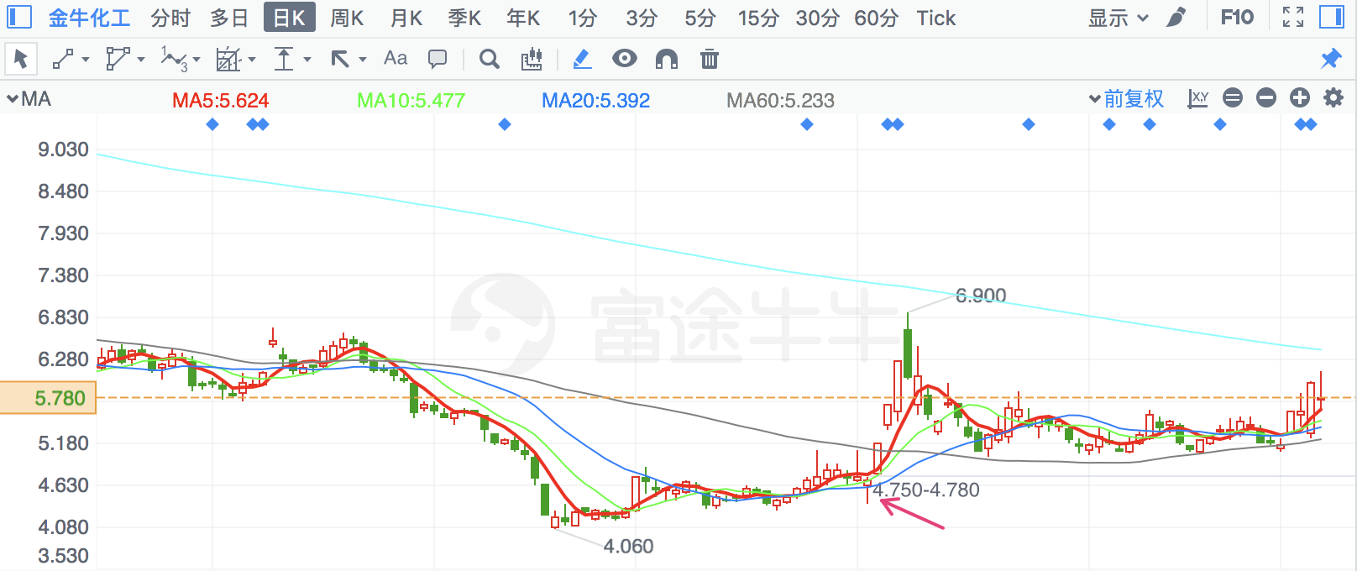

|  |  |  |
| --- | --- | --- |
| **2018/3/26** | **300390** | **天华超净** |

年线支撑

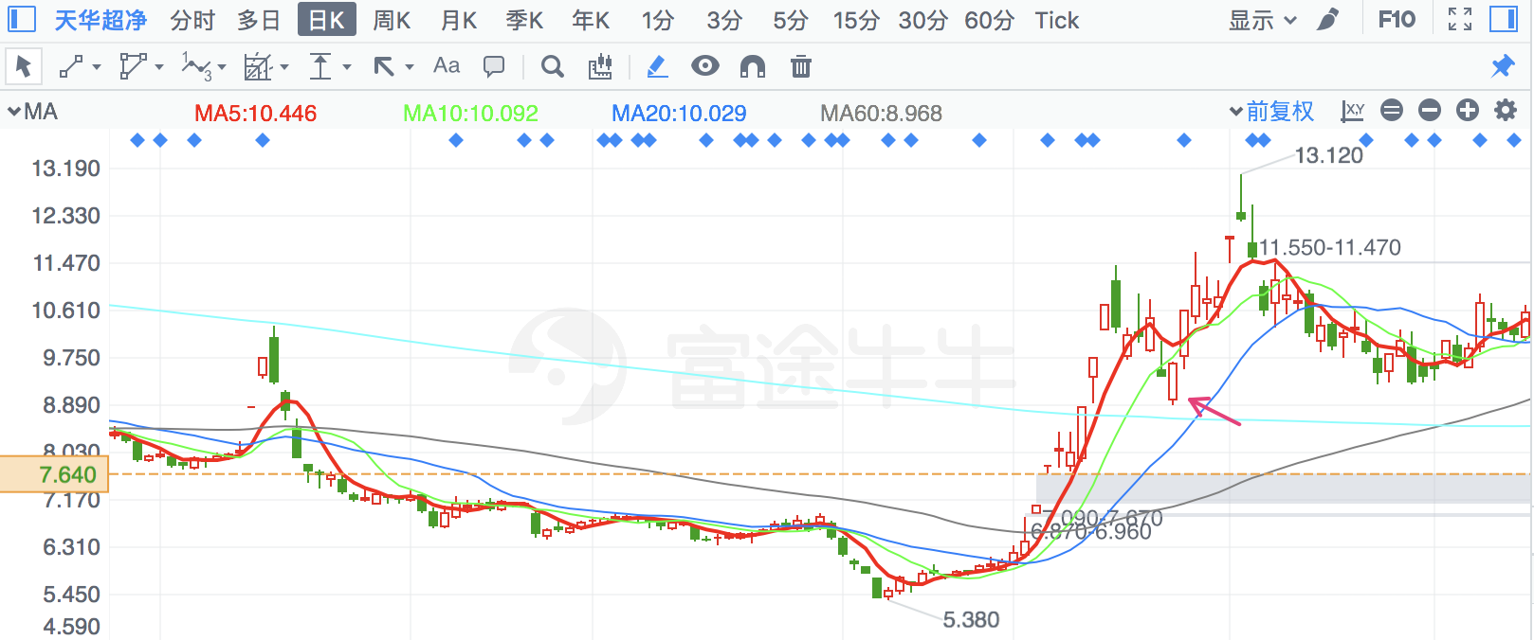

|  |  |  |
| --- | --- | --- |
| **2018/3/23** | **603367** | **辰欣药业** |

月线支撑

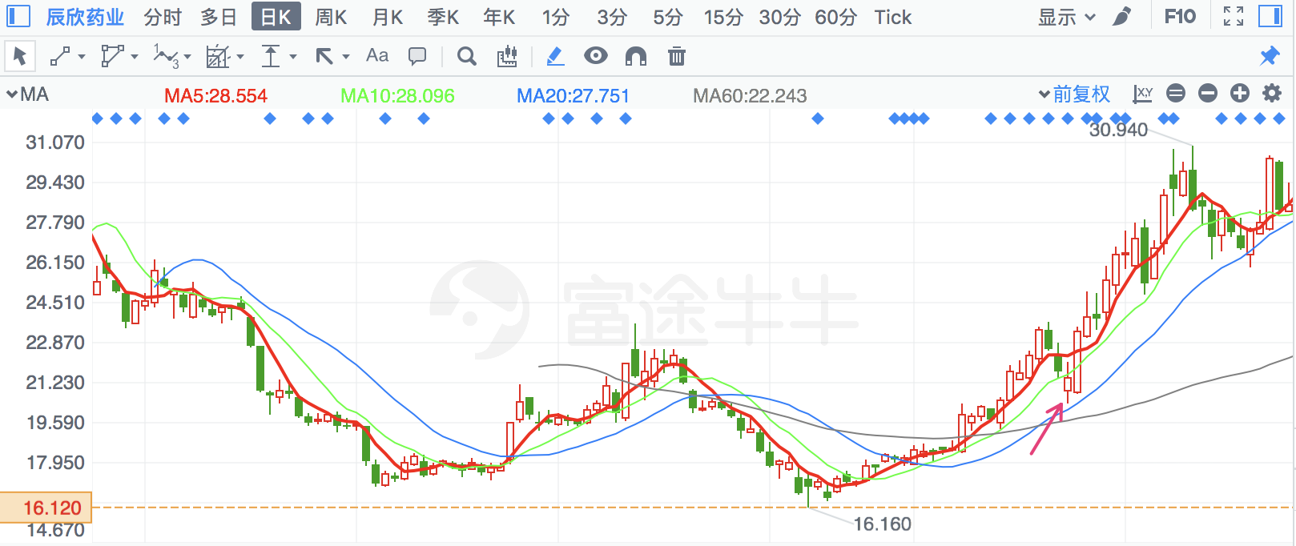

|  |  |  |
| --- | --- | --- |
| **2018/6/28** | **2584** | **西陇科学** |

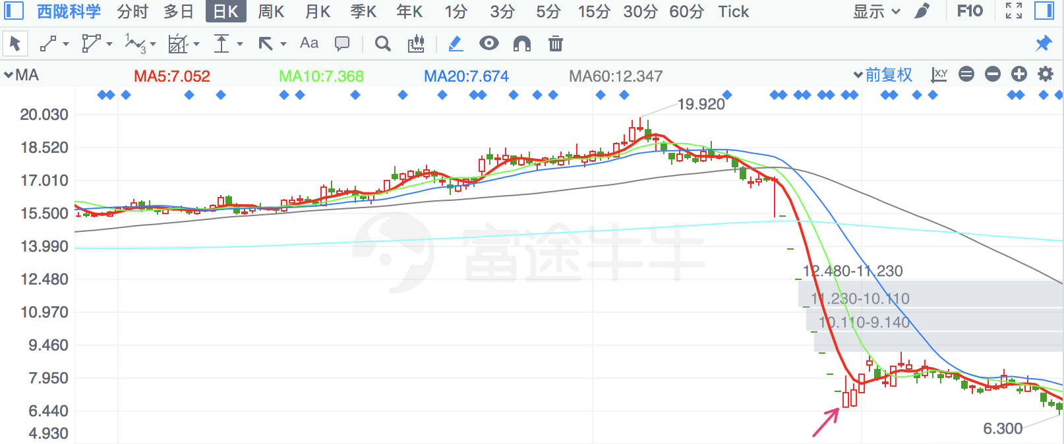

|  |  |  |
| --- | --- | --- |
| **2018/4/11** | **600555** | **海航创新** |

月线、季线支撑

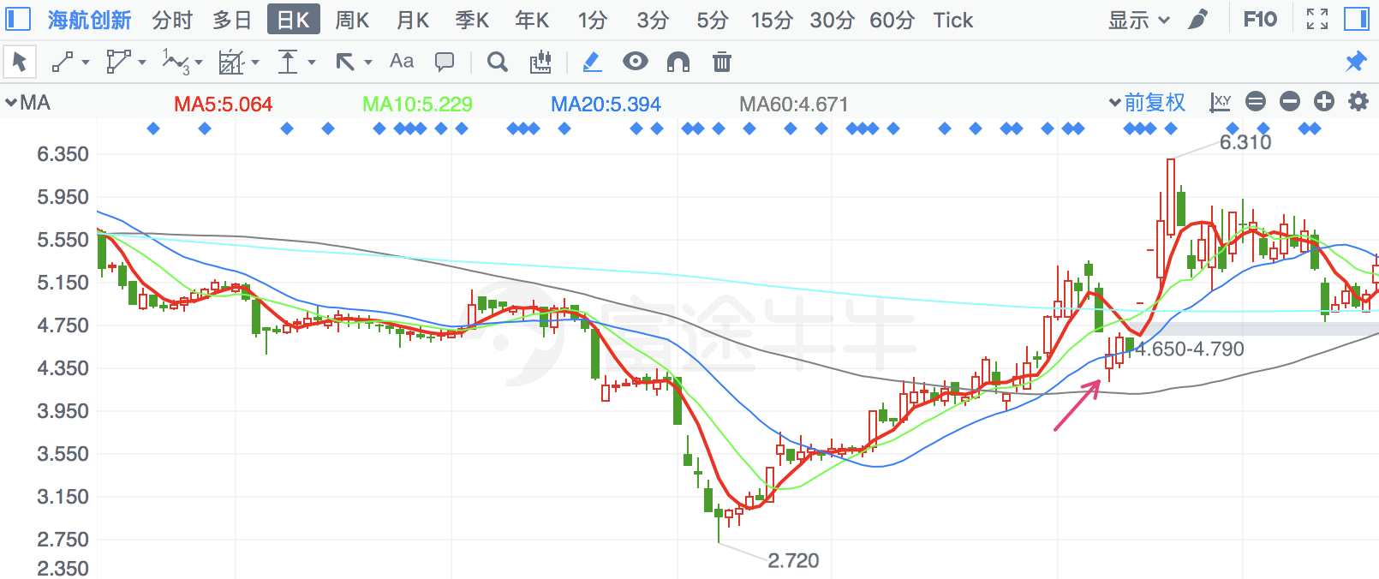

|  |  |  |
| --- | --- | --- |
| **2018/3/26** | **300496** | **中科创达** |

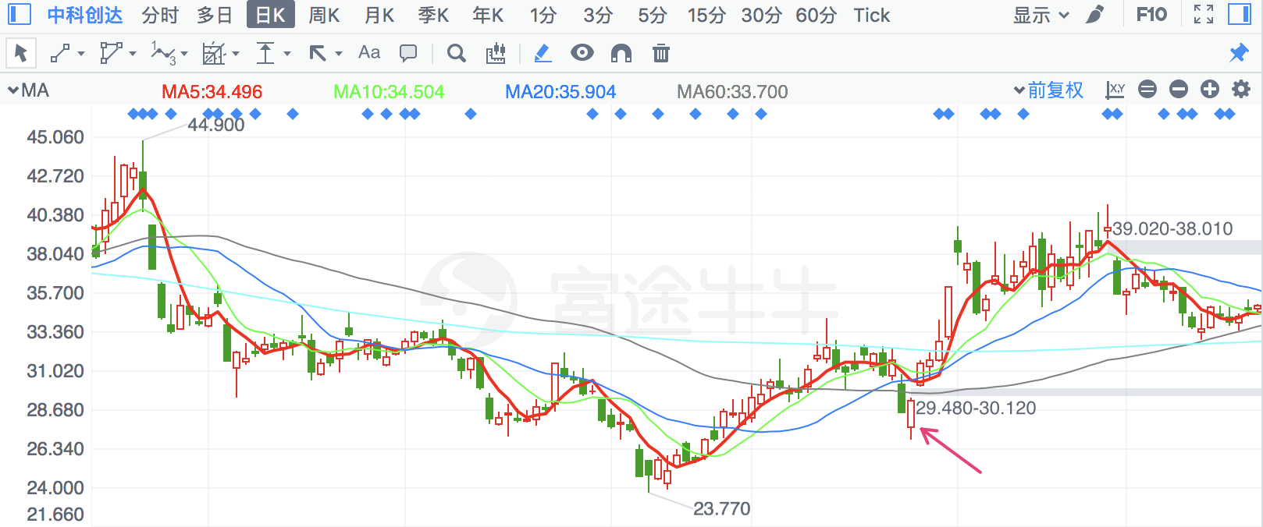

|  |  |  |
| --- | --- | --- |
| **2018/2/12** | **600810** | **神马股份** |

月线、年线支撑

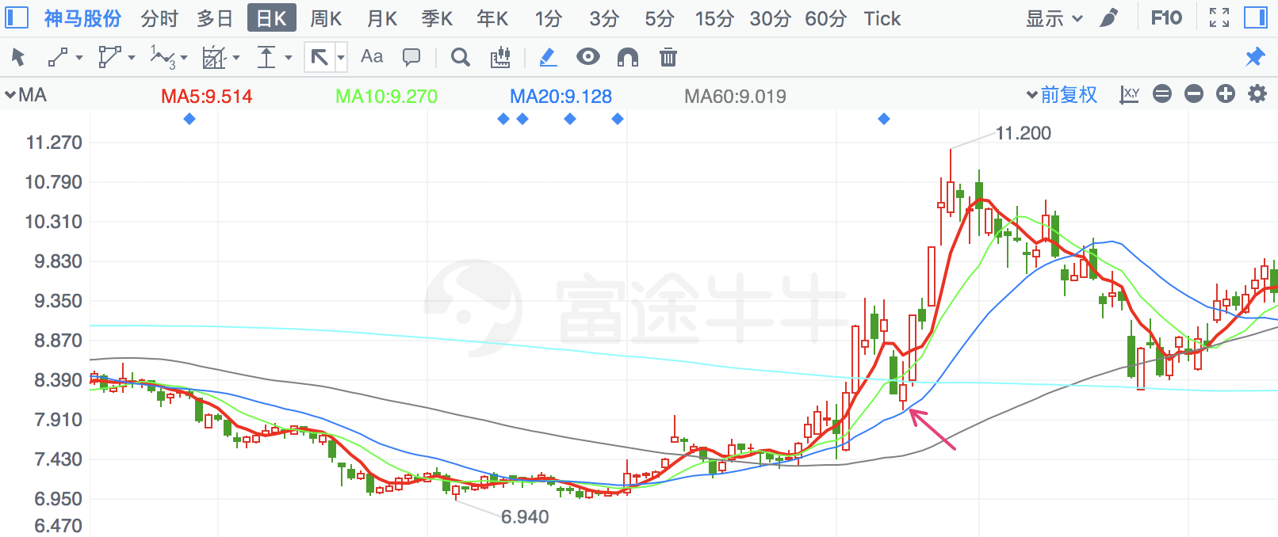

|  |  |  |
| --- | --- | --- |
| **2018/2/8** | **603356** | **华菱精工** |

次新股新低

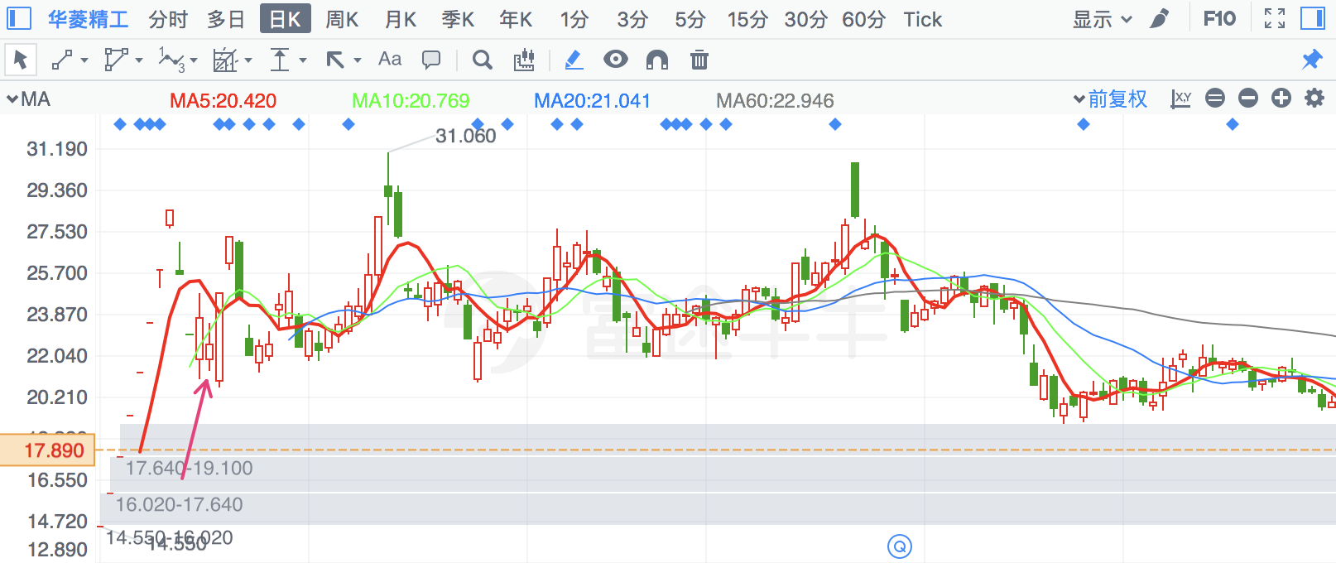

|  |  |  |
| --- | --- | --- |
| **2018/3/26** | **300149** | **量子生物** |

有季线支撑

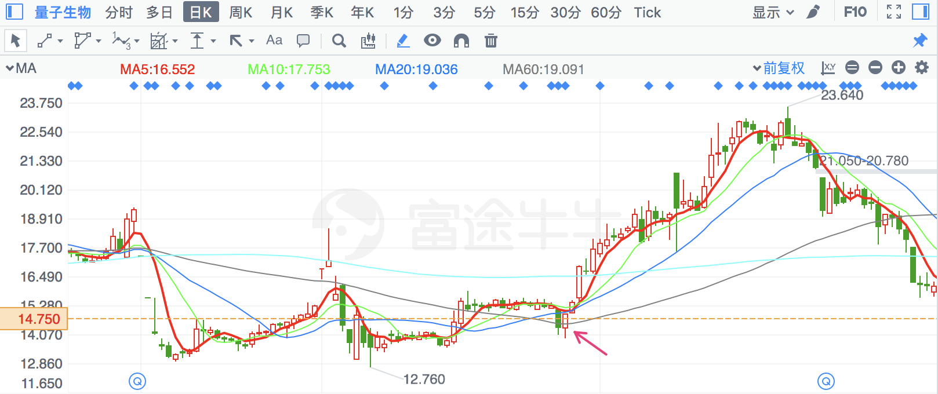

|  |  |  |
| --- | --- | --- |
| **2018/6/20** | **600385** | **山东金泰** |

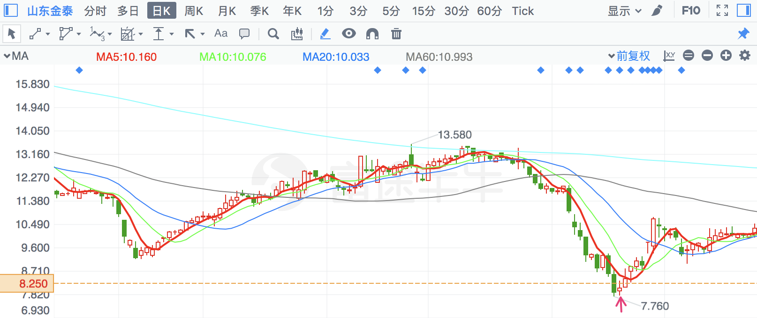

|  |  |  |
| --- | --- | --- |
| **2018/5/16** | **2604** | **\*ST龙力** |

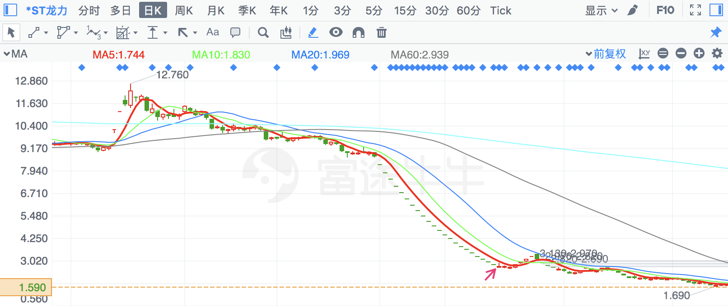

|  |  |  |
| --- | --- | --- |
| **2018/7/6** | **600810** | **神马股份** |

季线支撑

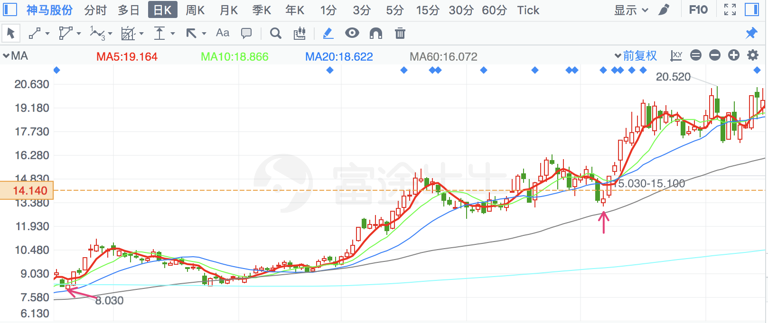

|  |  |  |
| --- | --- | --- |
| **2018/2/8** | **600596** | **新安股份** |

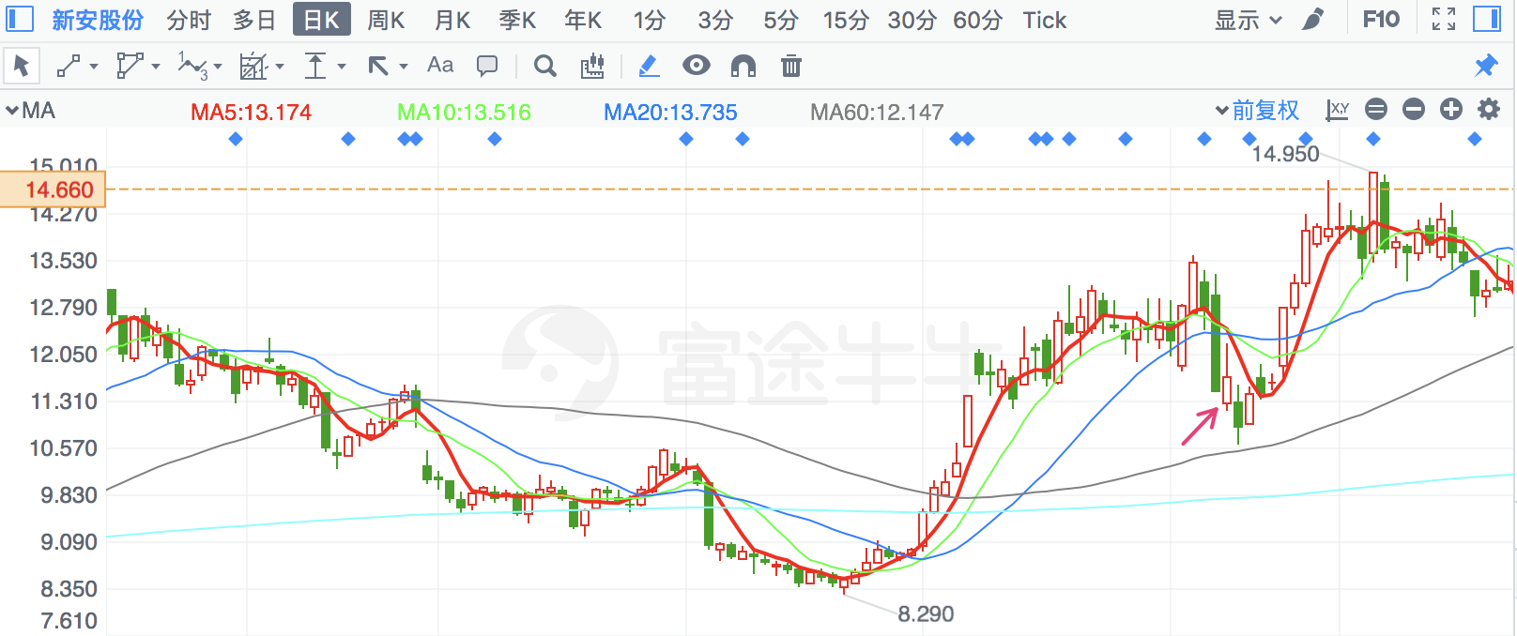

|  |  |  |
| --- | --- | --- |
| **2018/3/26** | **300557** | **理工光科** |

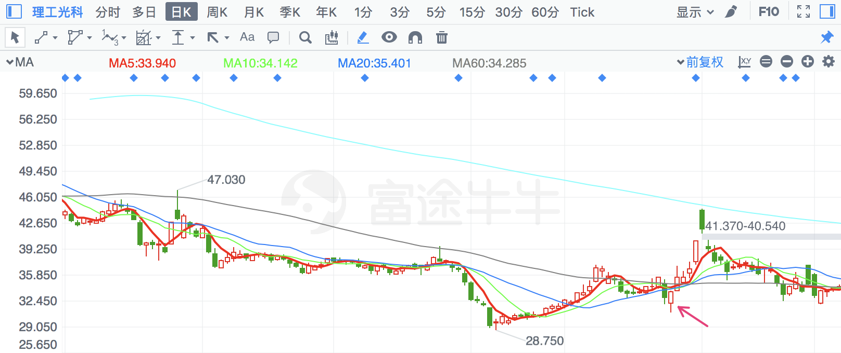

|  |  |  |
| --- | --- | --- |
| **2018/6/20** | **300648** | **星云股份** |

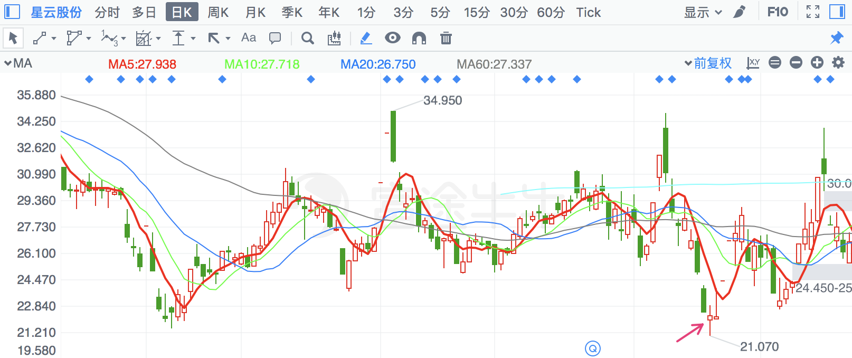

|  |  |  |
| --- | --- | --- |
| **2018/3/26** | **603912** | **佳力图** |

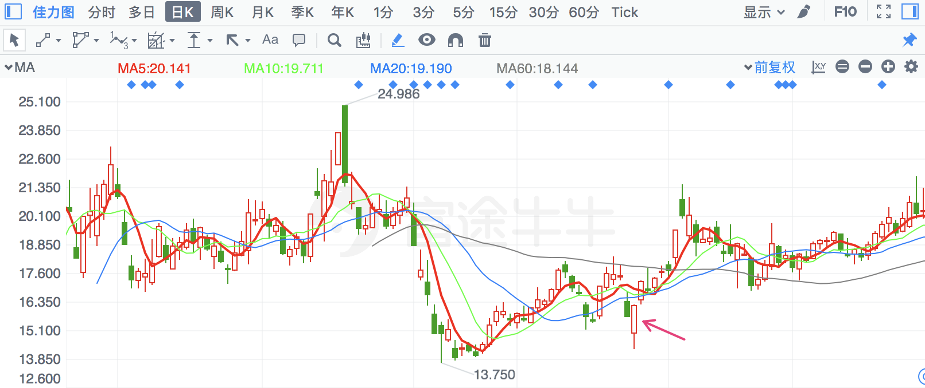

|  |  |  |
| --- | --- | --- |
| **2018/3/26** | **710** | **贝瑞基因** |

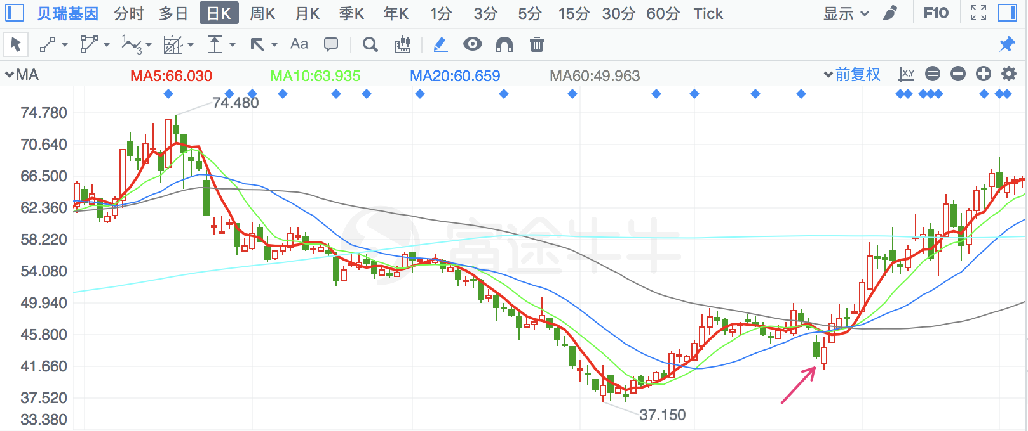

|  |  |  |
| --- | --- | --- |
| **2018/7/6** | **300705** | **九典制药** |

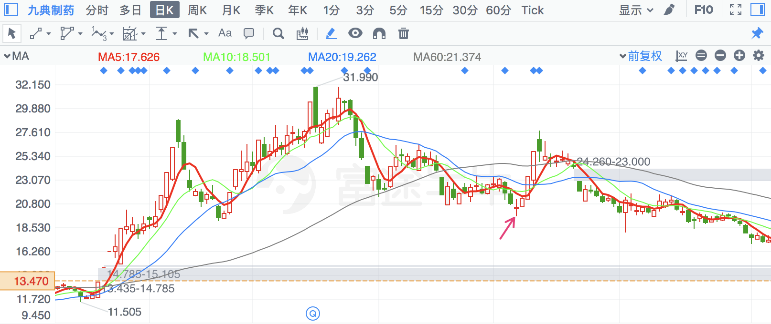

|  |  |  |
| --- | --- | --- |
| **2018/3/26** | **2675** | **东诚药业** |

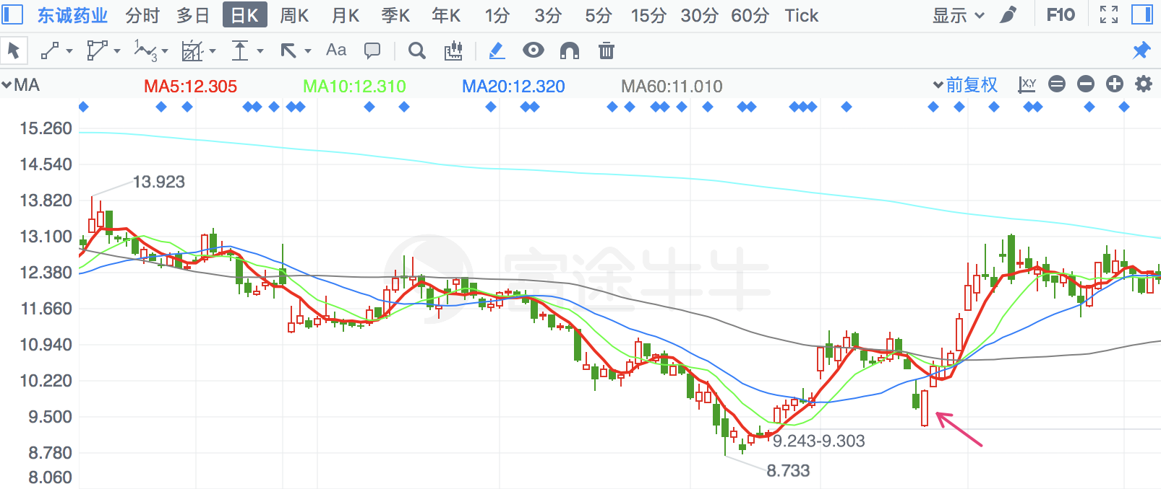

|  |  |  |
| --- | --- | --- |
| **2018/6/19** | **2562** | **兄弟科技** |

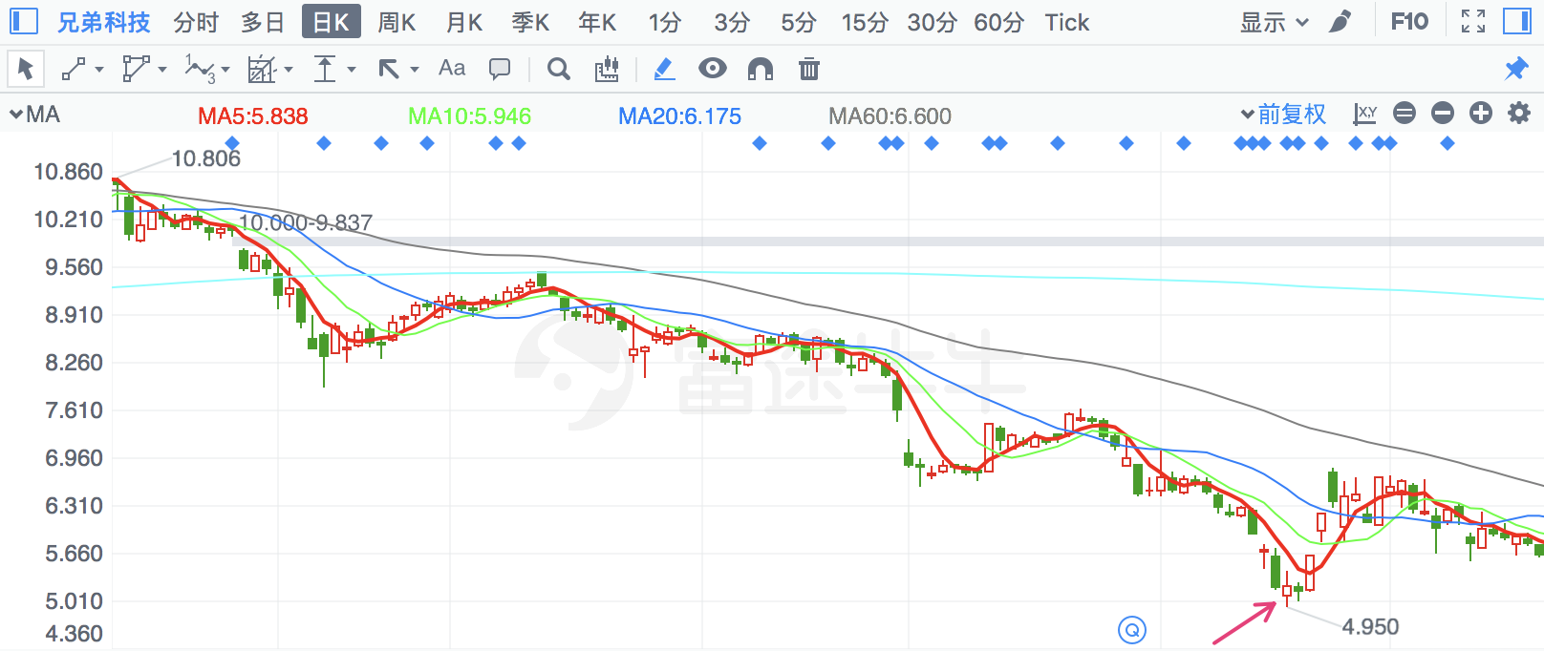

|  |  |  |
| --- | --- | --- |
| **2018/2/7** | **300065** | **海兰信** |

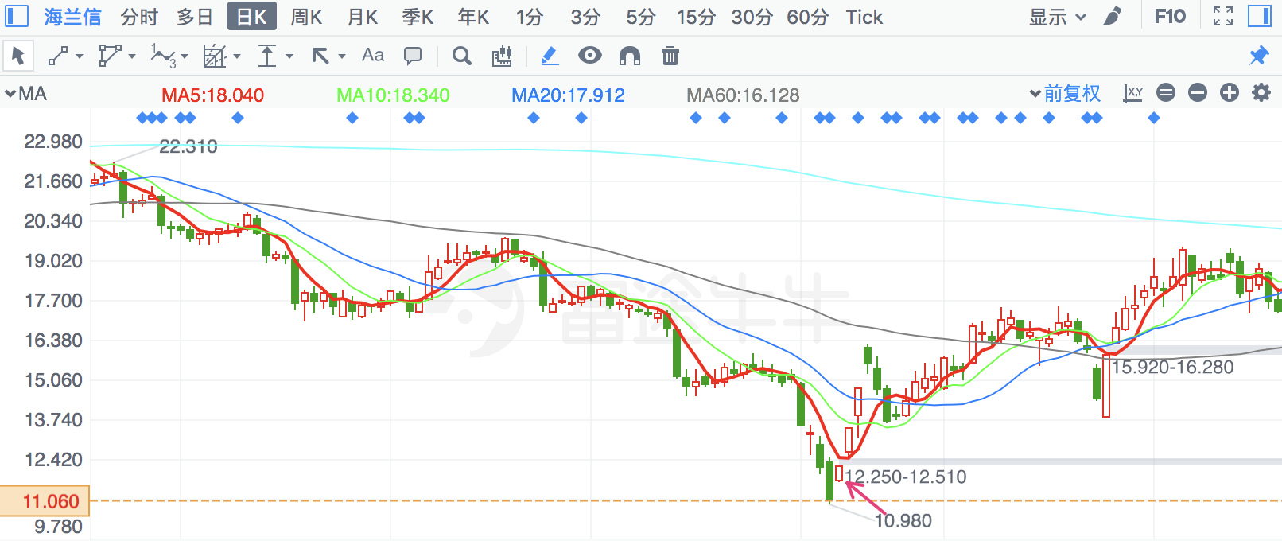

|  |  |  |
| --- | --- | --- |
| **2018/3/26** | **300603** | **立昂技术** |

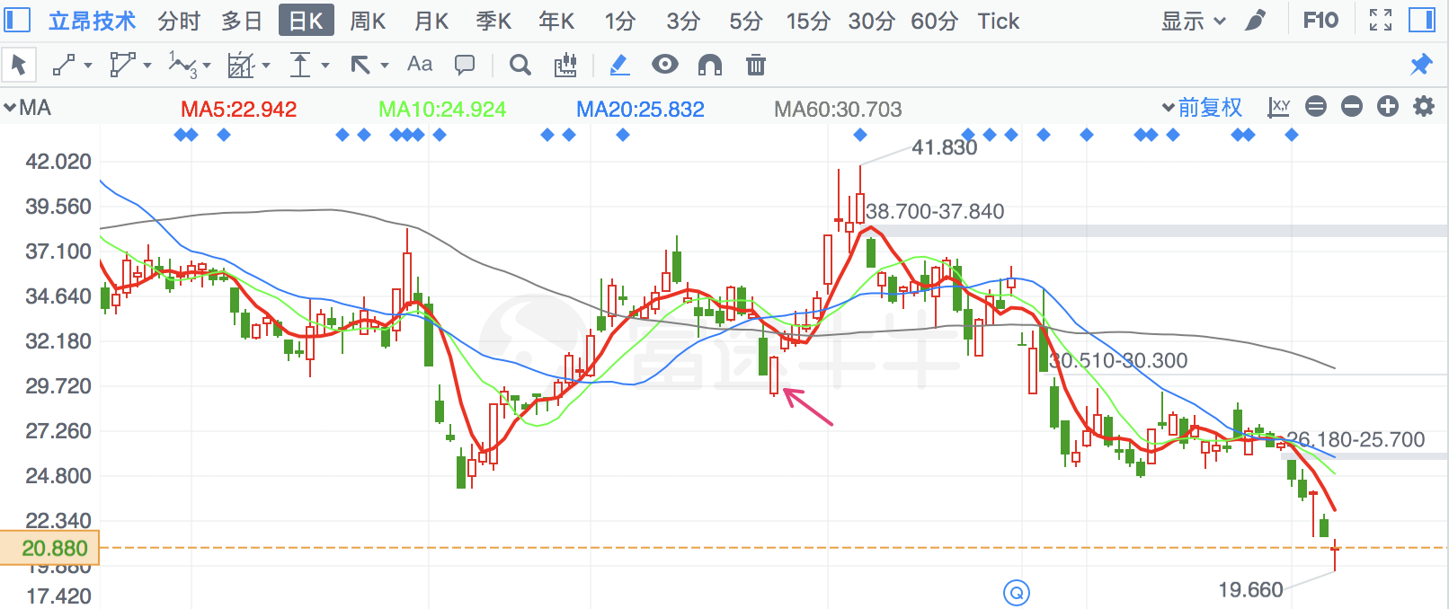

|  |  |  |
| --- | --- | --- |
| **2018/2/28** | **2925** | **盈趣科技** |

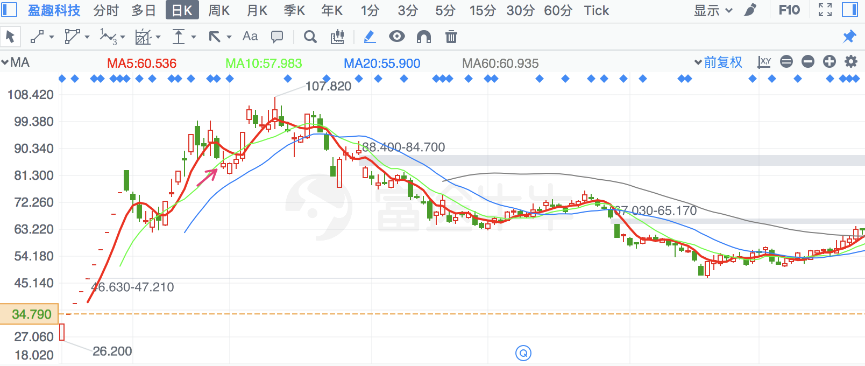

|  |  |  |
| --- | --- | --- |
| **2018/3/23** | **603266** | **天龙股份** |

倒锤子线

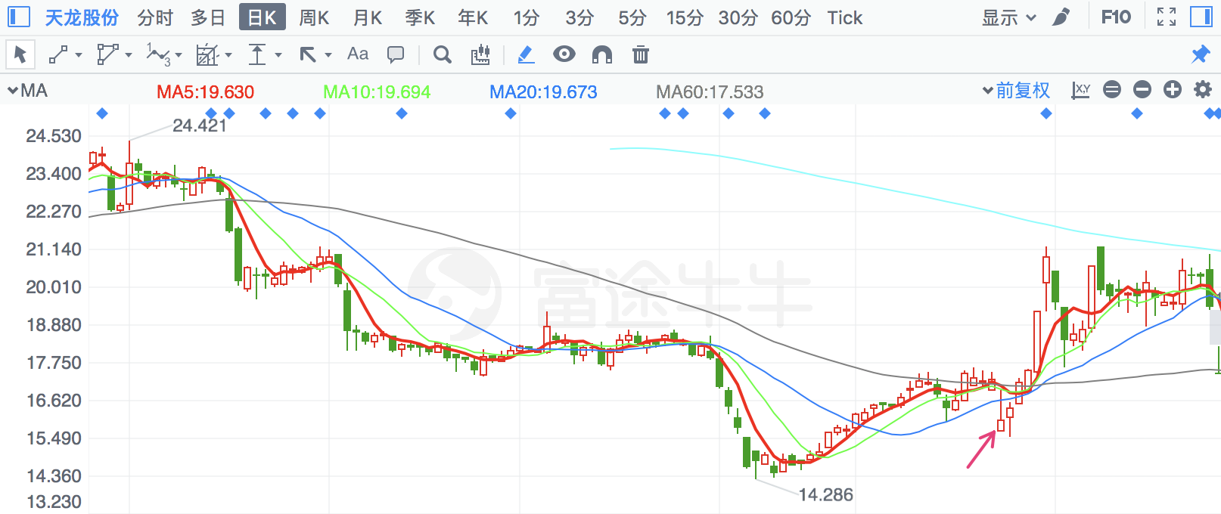

|  |  |  |
| --- | --- | --- |
| **2018/2/8** | **2236** | **大华股份** |

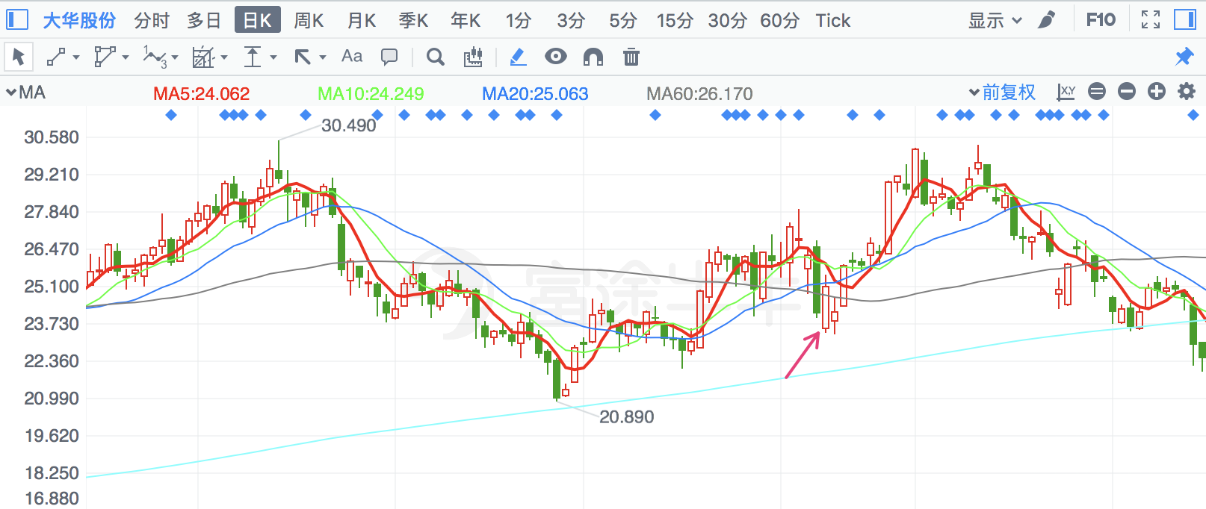

|  |  |  |
| --- | --- | --- |
| **2018/6/22** | **300225** | **金力泰** |

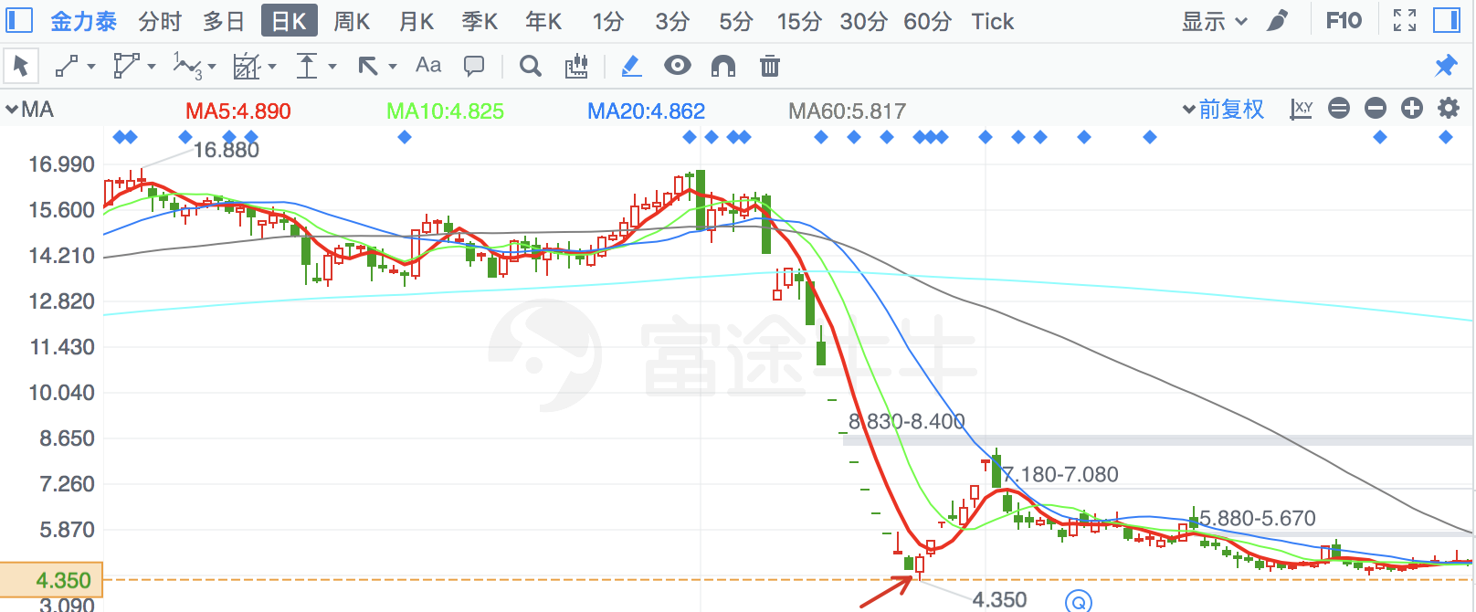

|  |  |  |
| --- | --- | --- |
| **2018/4/23** | **2877** | **智能自控** |

倒锤子线，有季线支撑

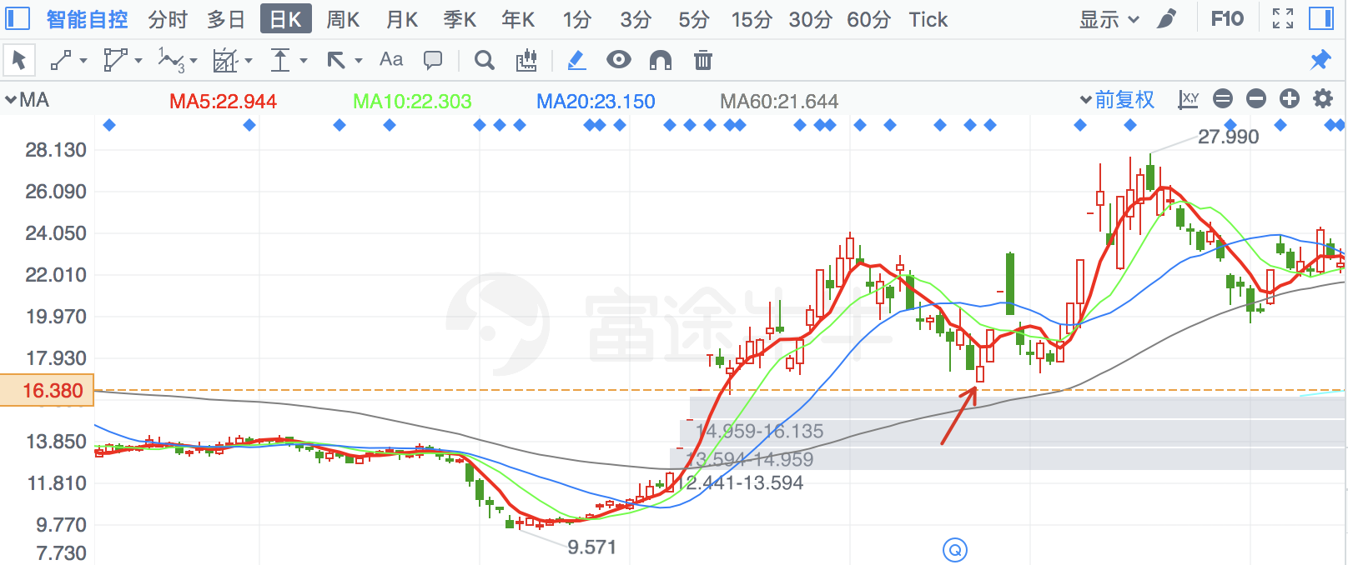

|  |  |  |
| --- | --- | --- |
| **2018/2/22** | **2907** | **华森制药** |

有季线支撑

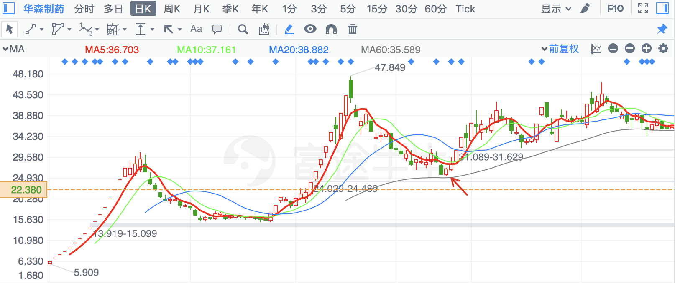

|  |  |  |
| --- | --- | --- |
| **2018/2/7** | **600841** | **上柴股份** |

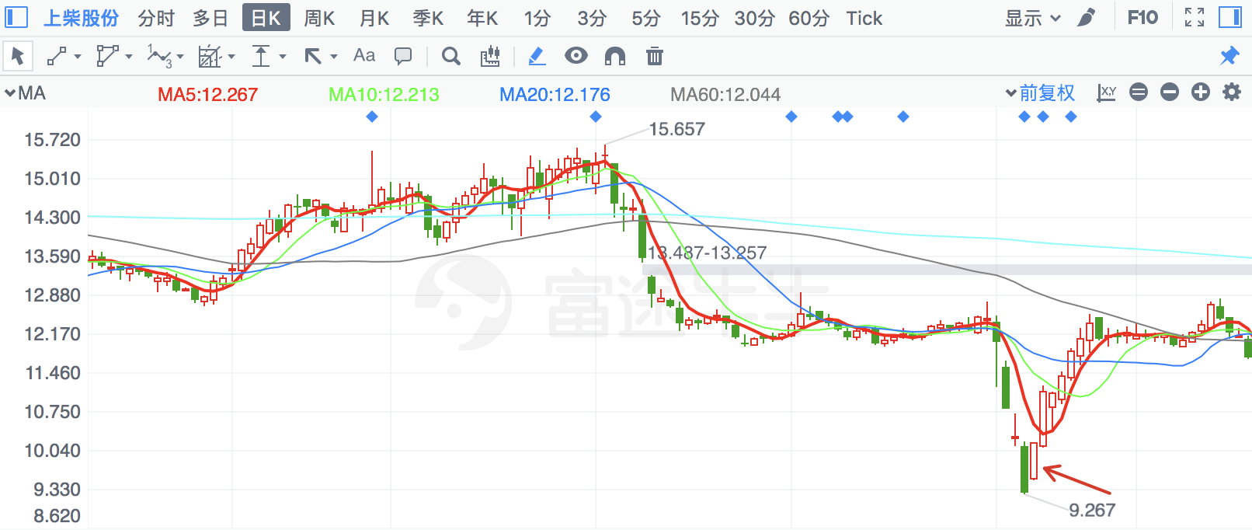

|  |  |  |
| --- | --- | --- |
| **2018/4/9** | **300715** | **凯伦股份** |

有月线支撑

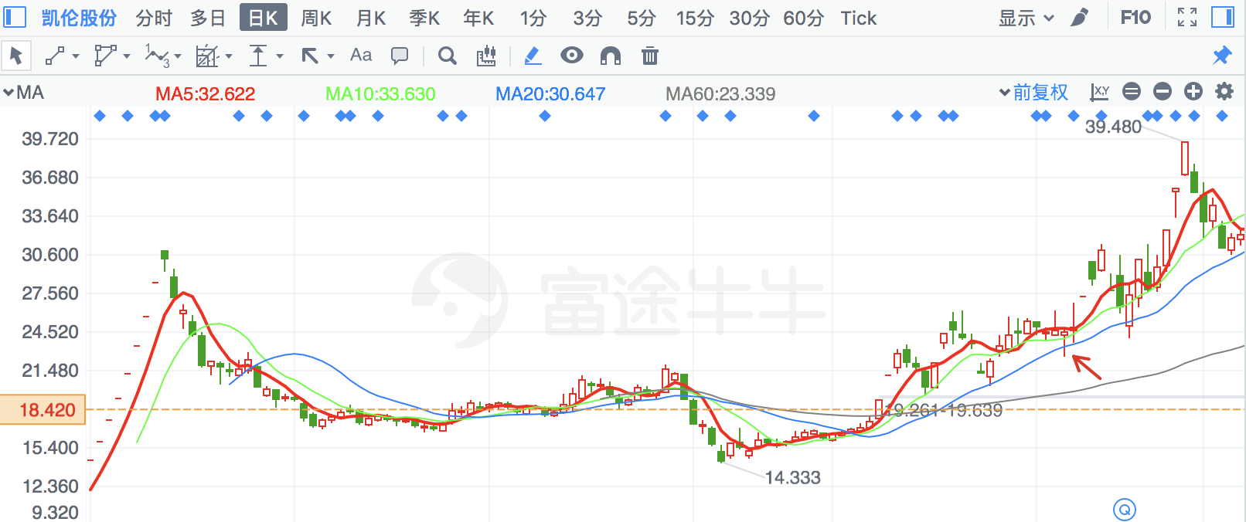

|  |  |  |
| --- | --- | --- |
| **2018/8/21** | **300659** | **中孚信息** |

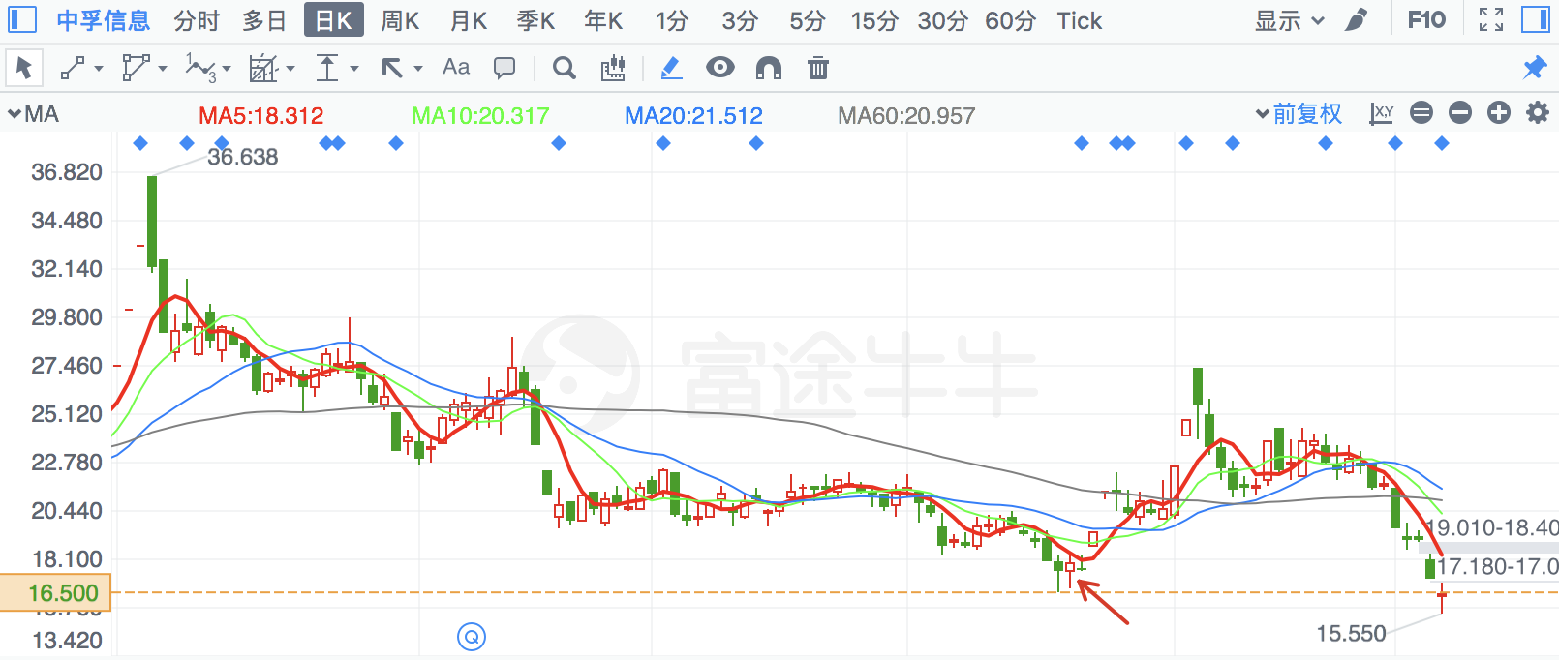

|  |  |  |
| --- | --- | --- |
| **2018/6/20** | **300571** | **平治信息** |

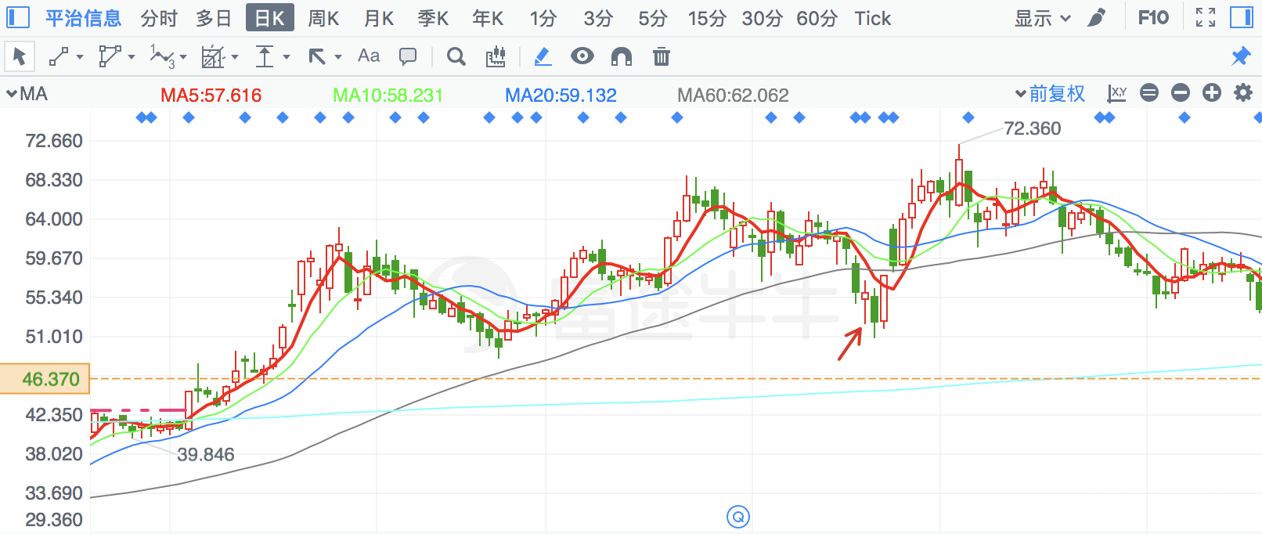

|  |  |  |
| --- | --- | --- |
| **2018/2/8** | **603959** | **百利科技** |

镊形底，有年线支撑

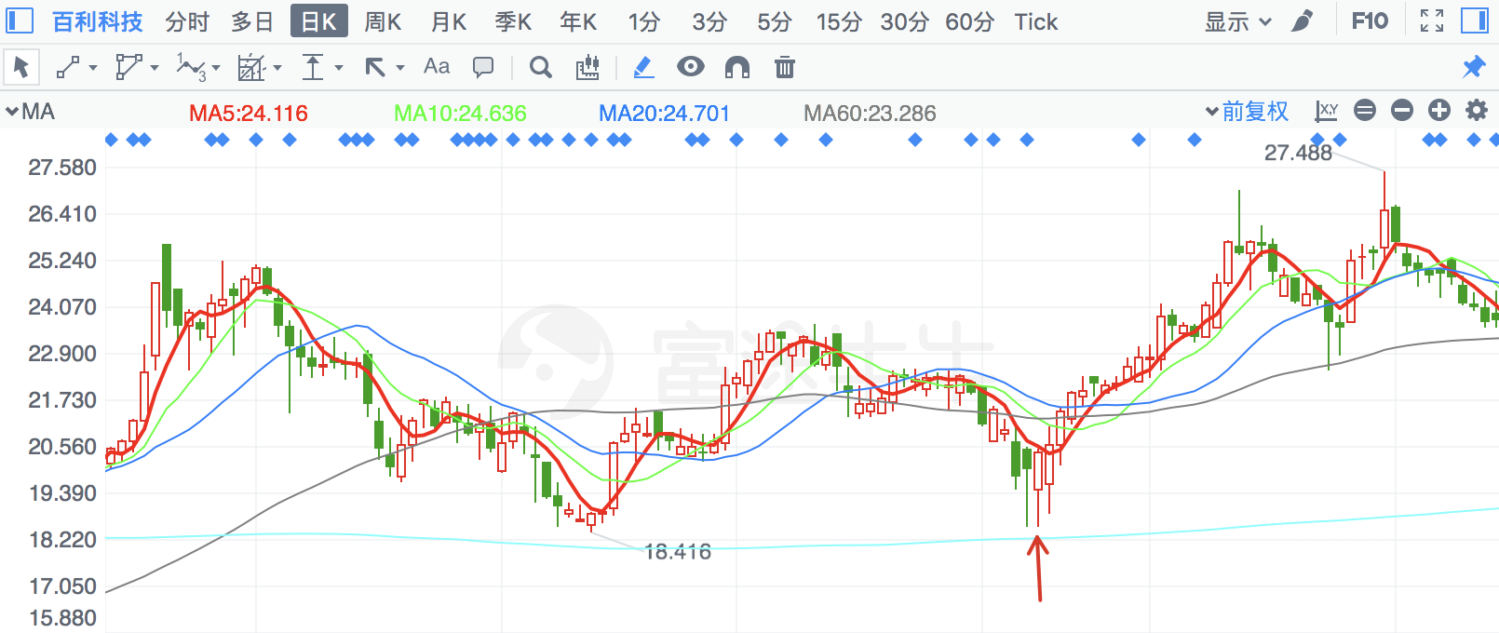

|  |  |  |
| --- | --- | --- |
| **2018/3/26** | **2815** | **崇达技术** |

有季线支撑

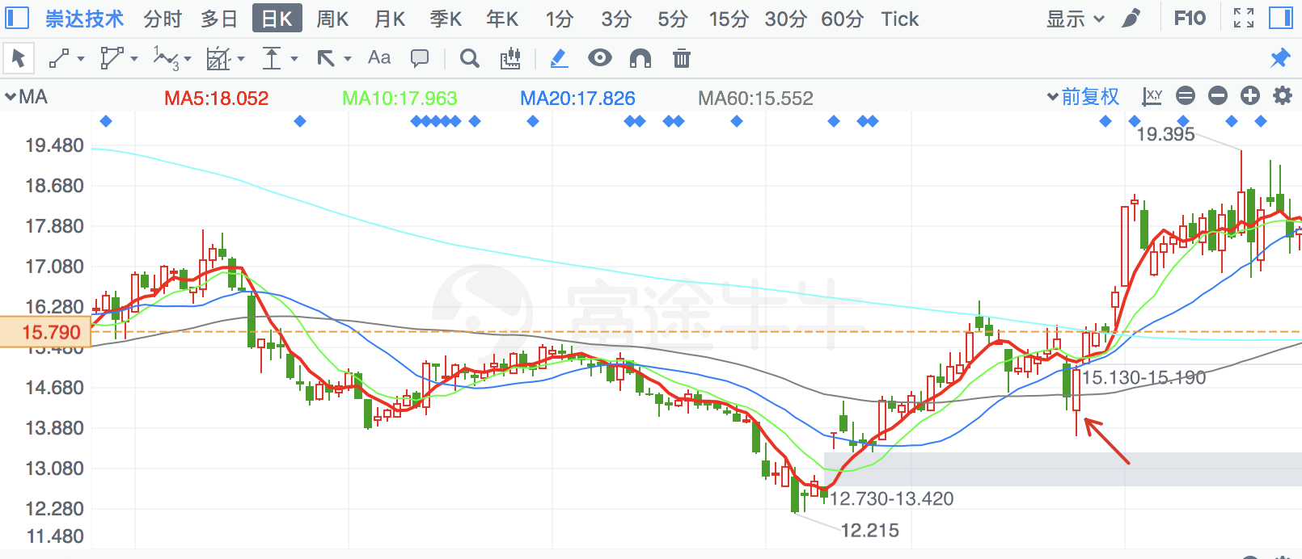

|  |  |  |
| --- | --- | --- |
| **2018/3/26** | **300098** | **高新兴** |

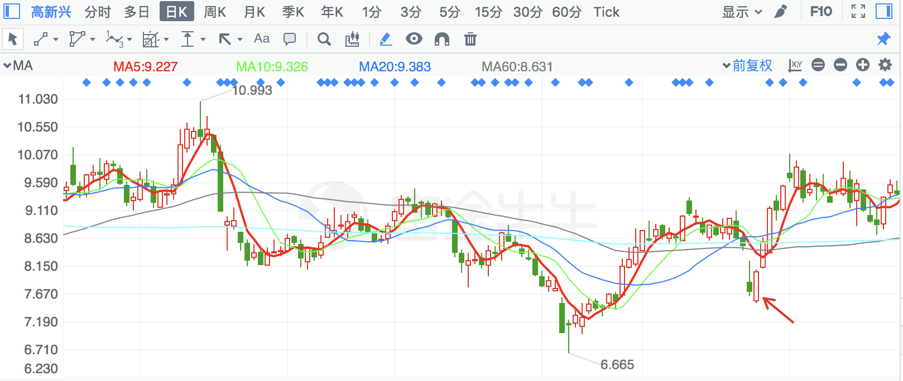

|  |  |  |
| --- | --- | --- |
| **2018/2/8** | **2776** | **柏堡龙** |

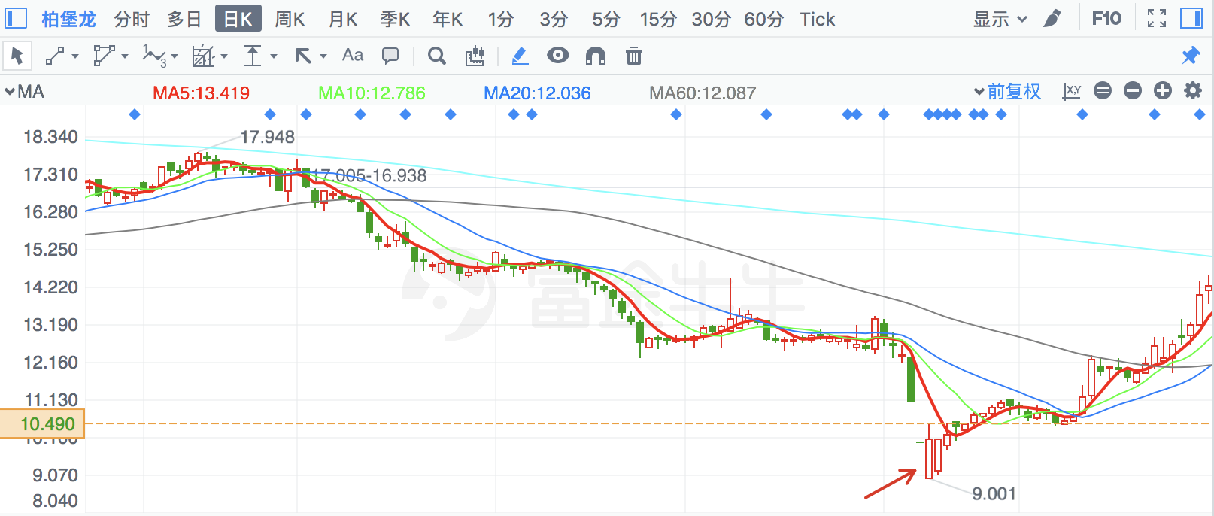

|  |  |  |
| --- | --- | --- |
| **2018/3/26** | **300075** | **数字政通** |

有前期底部支撑

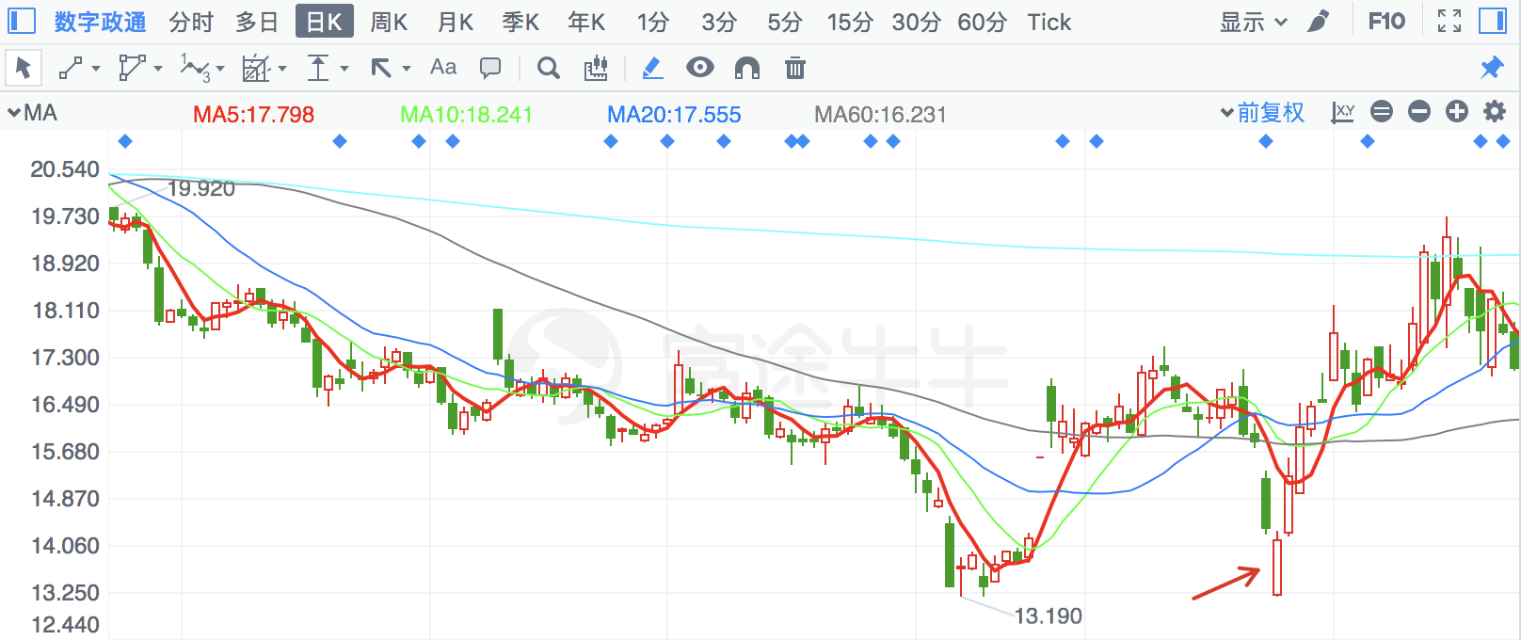

|  |  |  |
| --- | --- | --- |
| **2018/2/7** | **300151** | **昌红科技** |

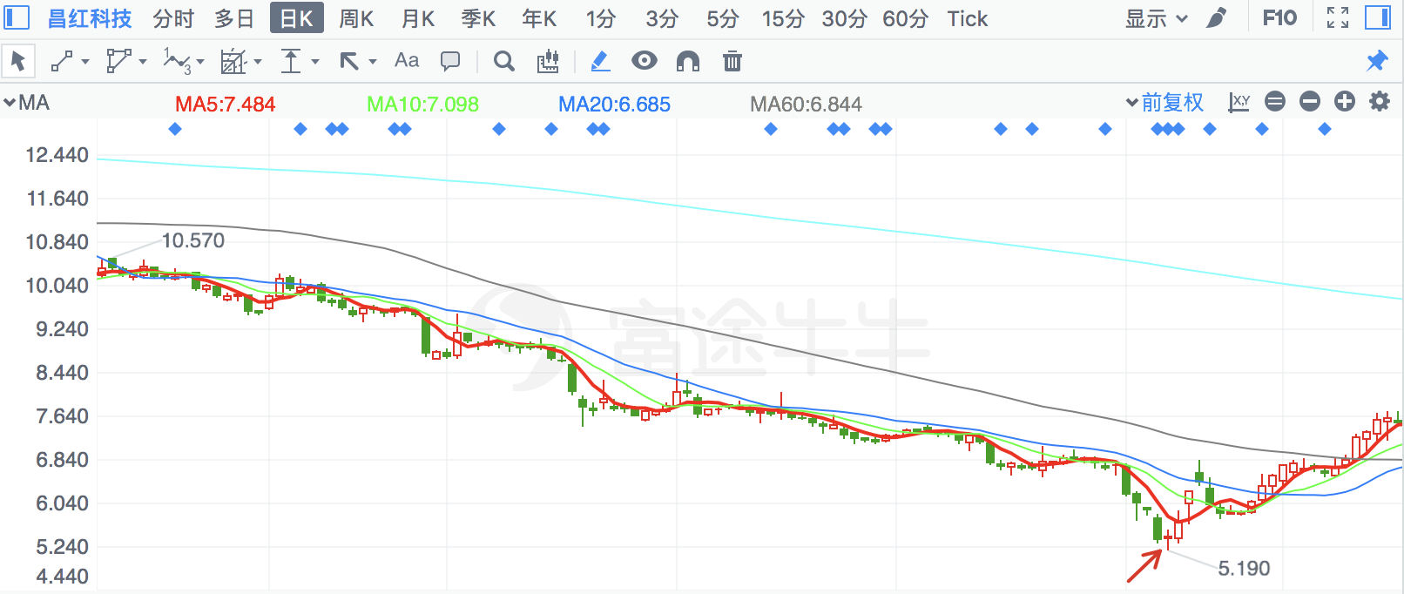

|  |  |  |
| --- | --- | --- |
| **2018/2/8** | **300153** | **科泰电源** |

镊形底

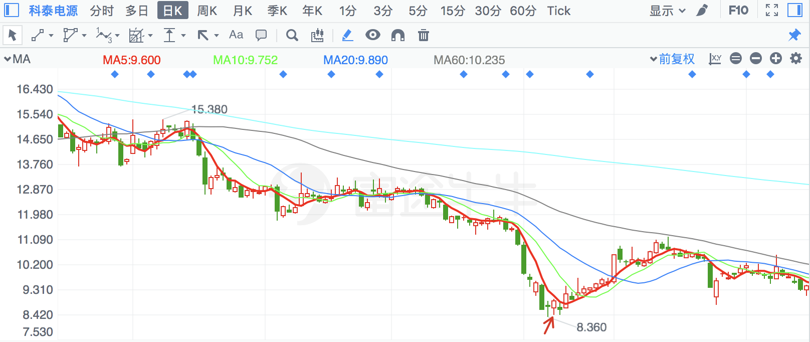

|  |  |  |
| --- | --- | --- |
| **2018/3/26** | **300078** | **思创医惠** |

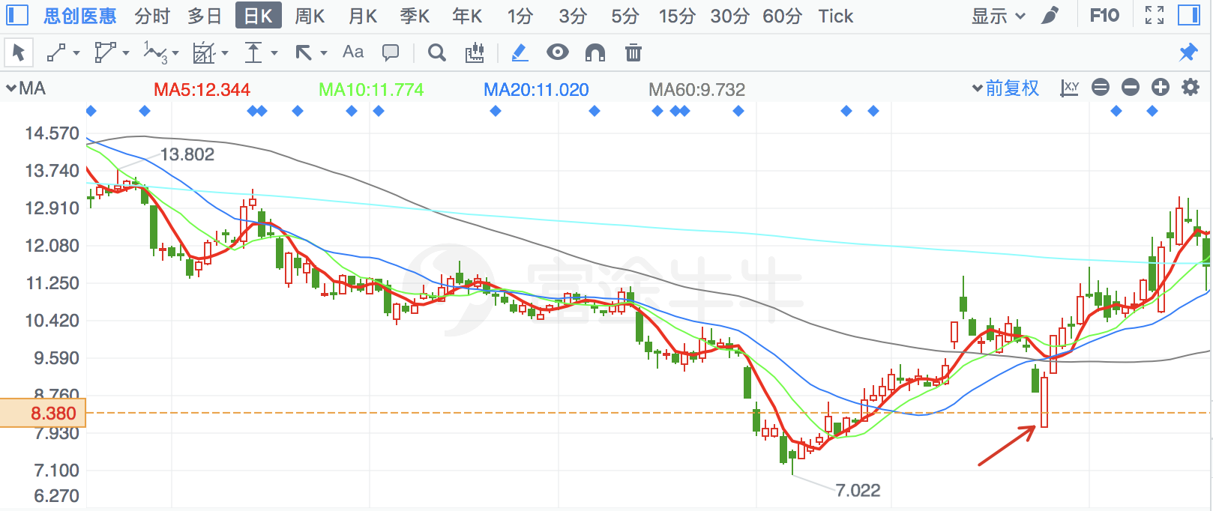

|  |  |  |
| --- | --- | --- |
| **2018/2/7** | **600645** | **中源协和** |

金针探底

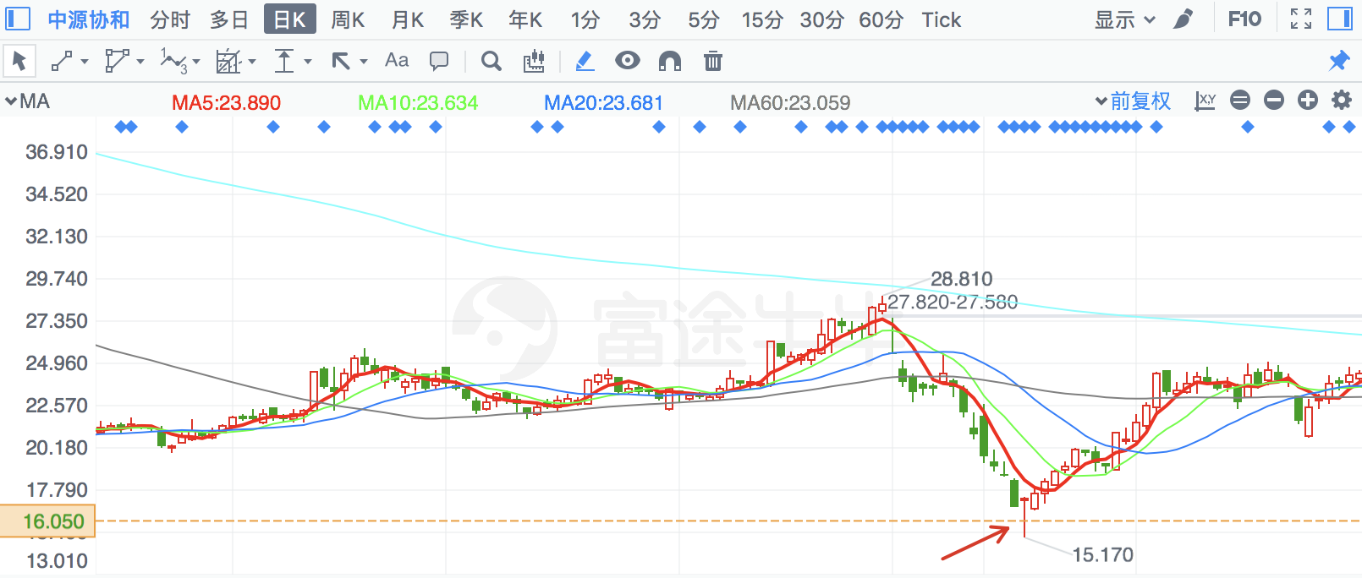

|  |  |  |
| --- | --- | --- |
| **2018/2/9** | **600242** | **中昌数据** |

金针探底

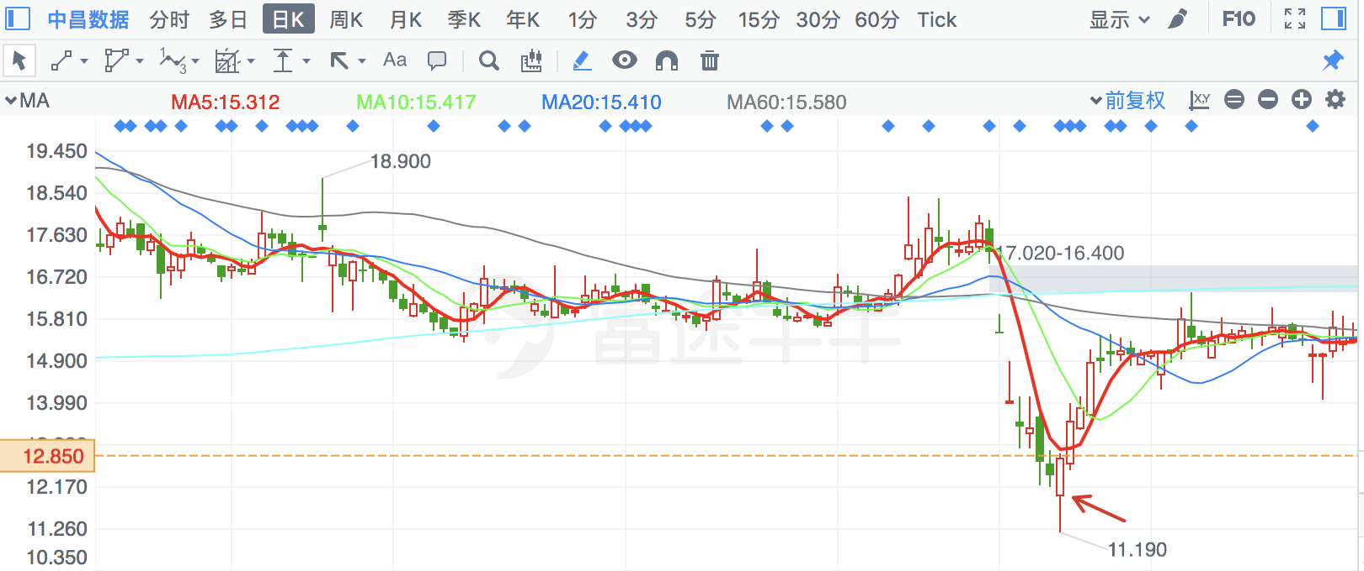

|  |  |  |
| --- | --- | --- |
| **2018/8/9** | **300601** | **康泰生物** |

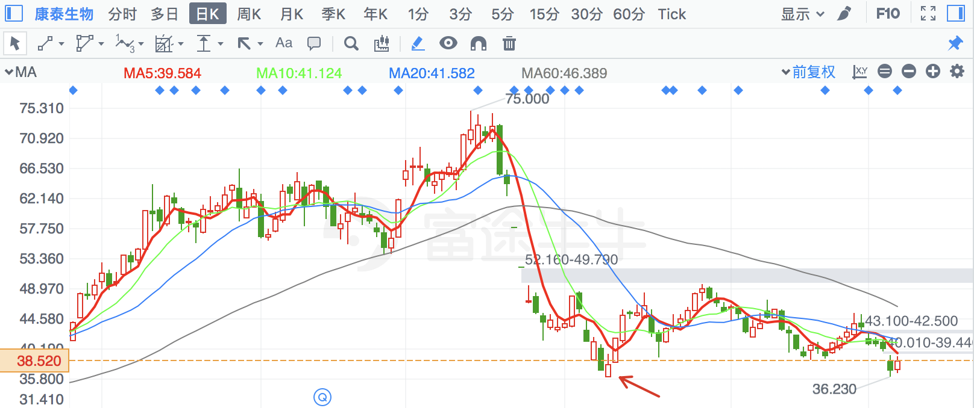

|  |  |  |
| --- | --- | --- |
| **2018/6/20** | **603067** | **振华股份** |

有前期底部支撑

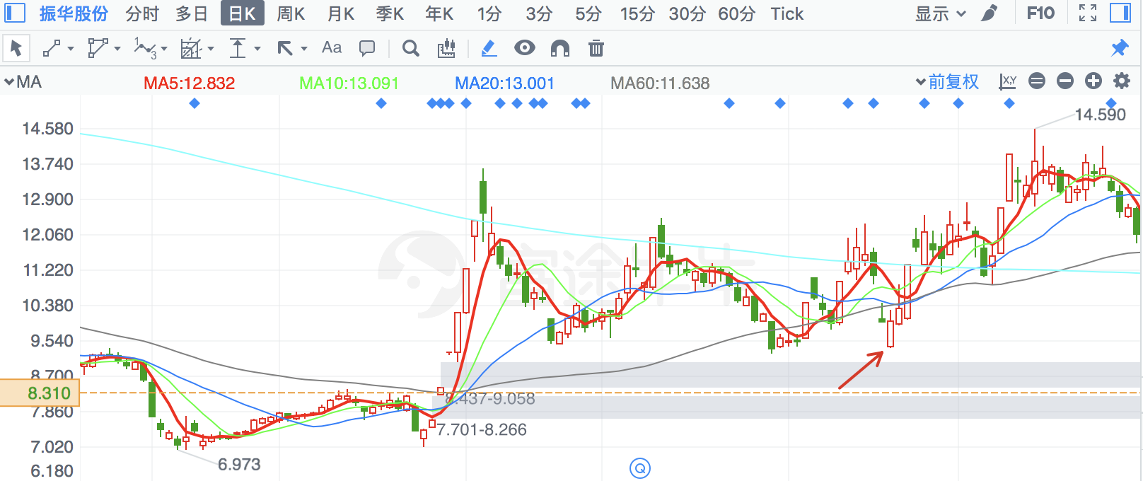

|  |  |  |
| --- | --- | --- |
| **2018/3/26** | **300460** | **惠伦晶体** |

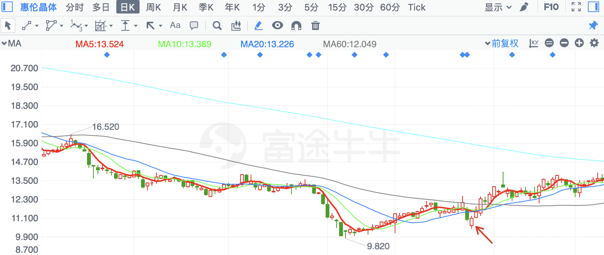

|  |  |  |
| --- | --- | --- |
| **2018/3/26** | **603729** | **龙韵股份** |

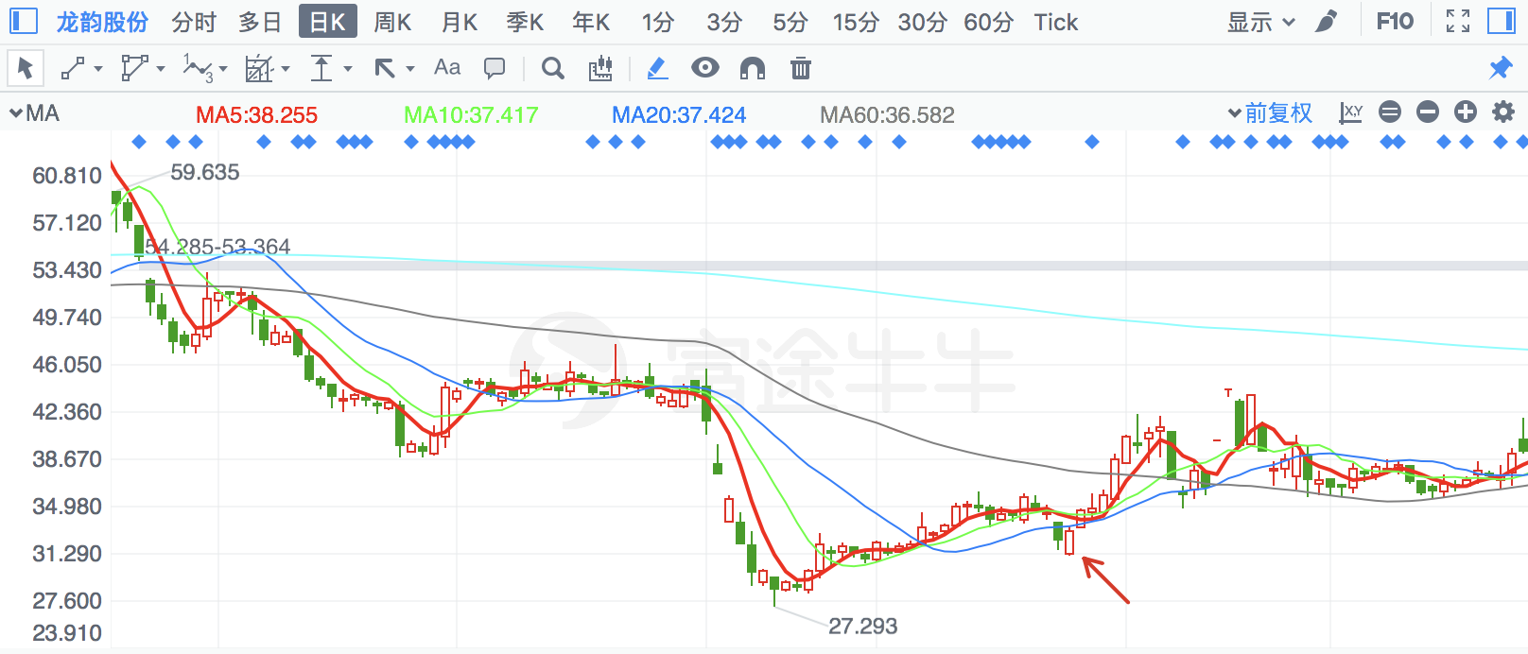

|  |  |  |
| --- | --- | --- |
| **2018/7/6** | **603367** | **辰欣药业** |

金针探底

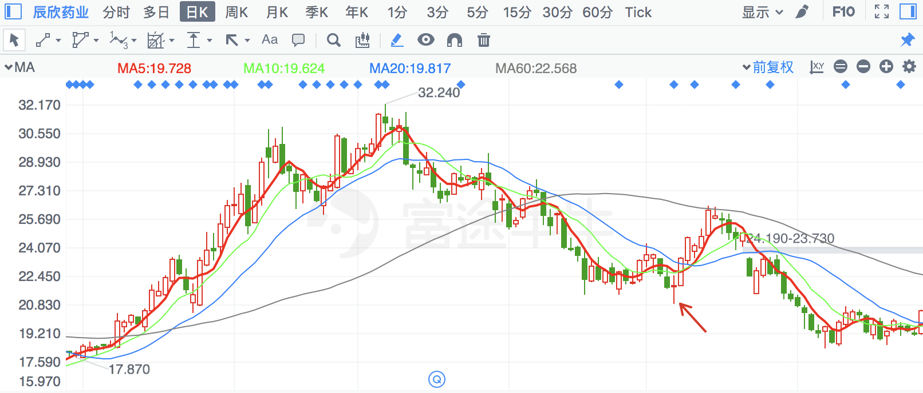

|  |  |  |
| --- | --- | --- |
| **2018/5/31** | **603535** | **嘉诚国际** |

月线支撑

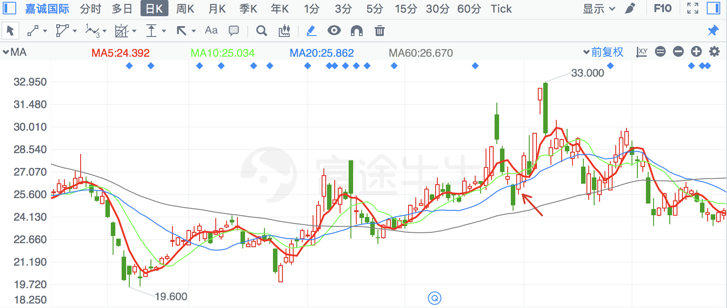

|  |  |  |
| --- | --- | --- |
| **2018/5/3** | **300235** | **方直科技** |

月线支撑

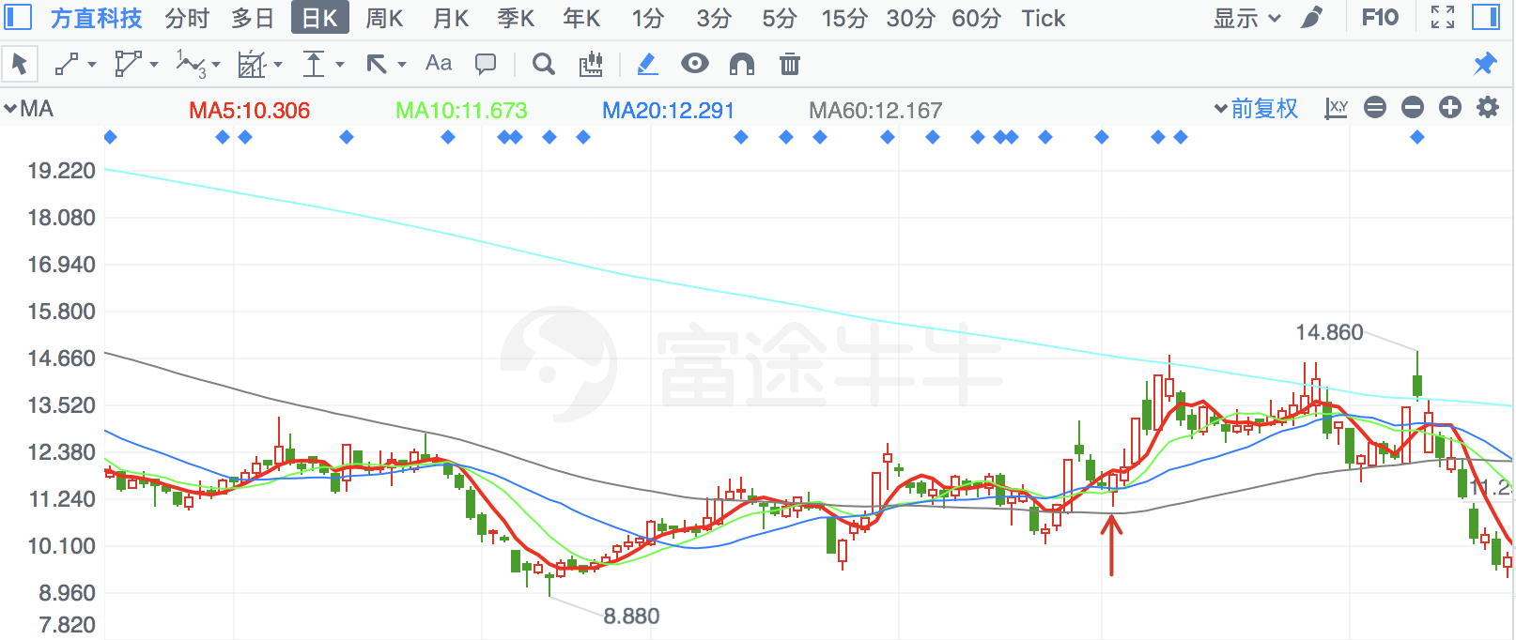

|  |  |  |
| --- | --- | --- |
| **2018/5/17** | **2795** | **永和智控** |

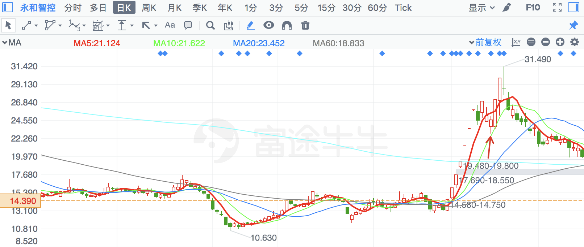

|  |  |  |
| --- | --- | --- |
| **2018/6/22** | **300128** | **锦富技术** |

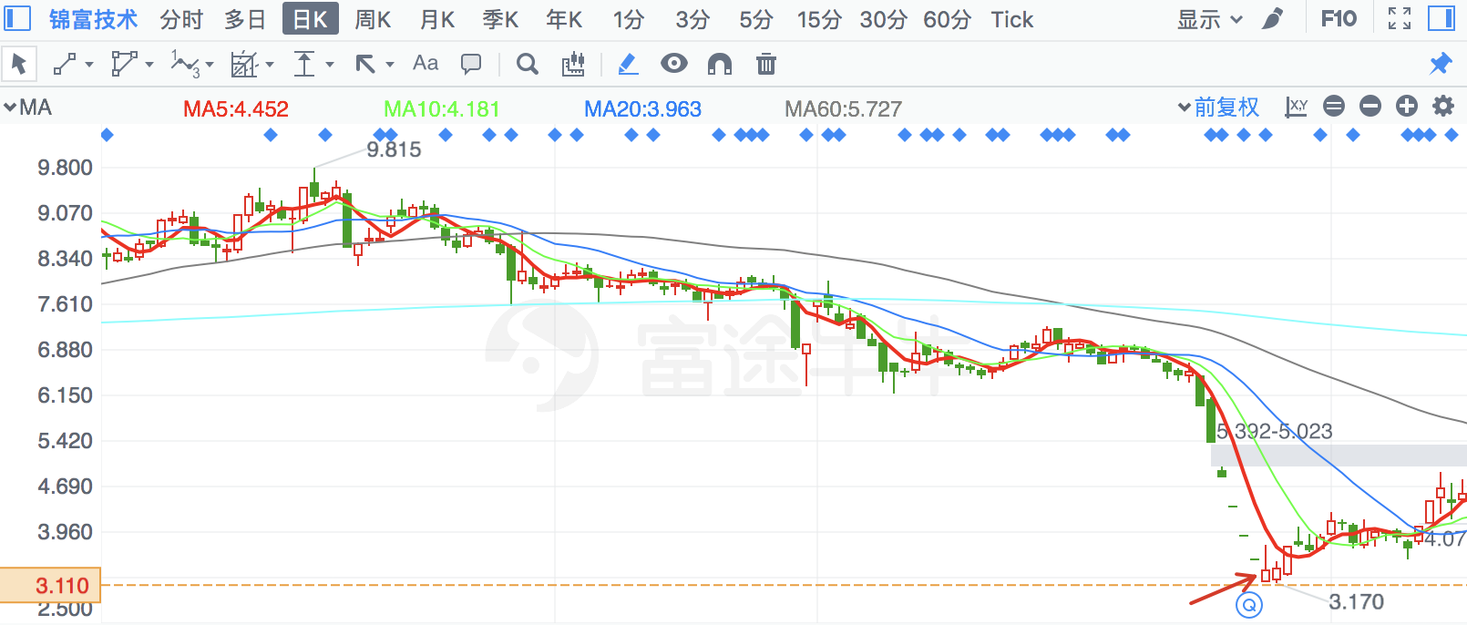

|  |  |  |
| --- | --- | --- |
| **2018/6/29** | **2782** | **可立克** |

季线支撑

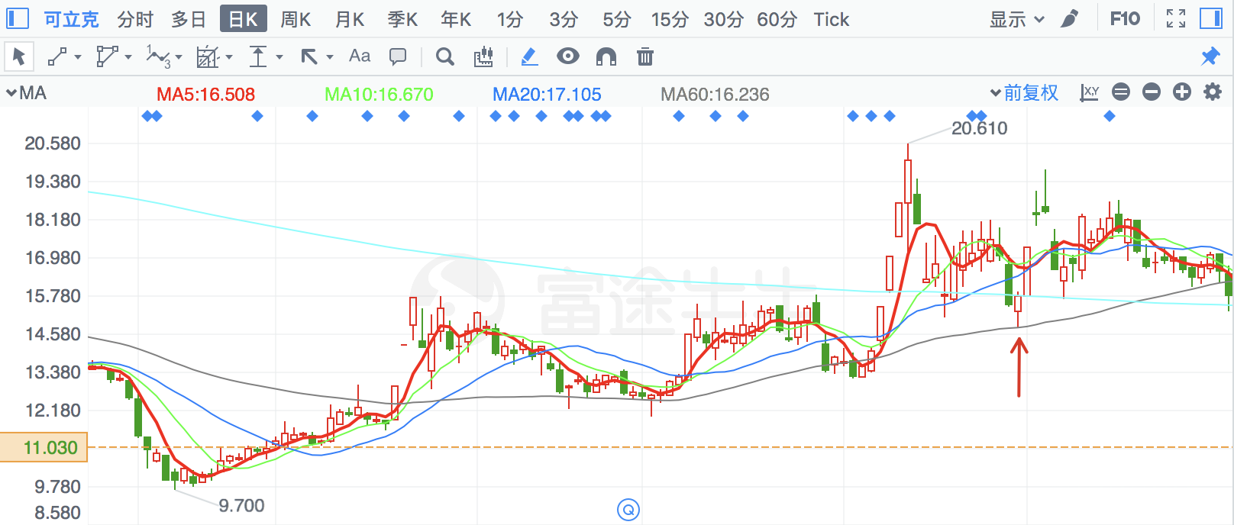

|  |  |  |
| --- | --- | --- |
| **2018/2/12** | **830** | **鲁西化工** |

季线支撑

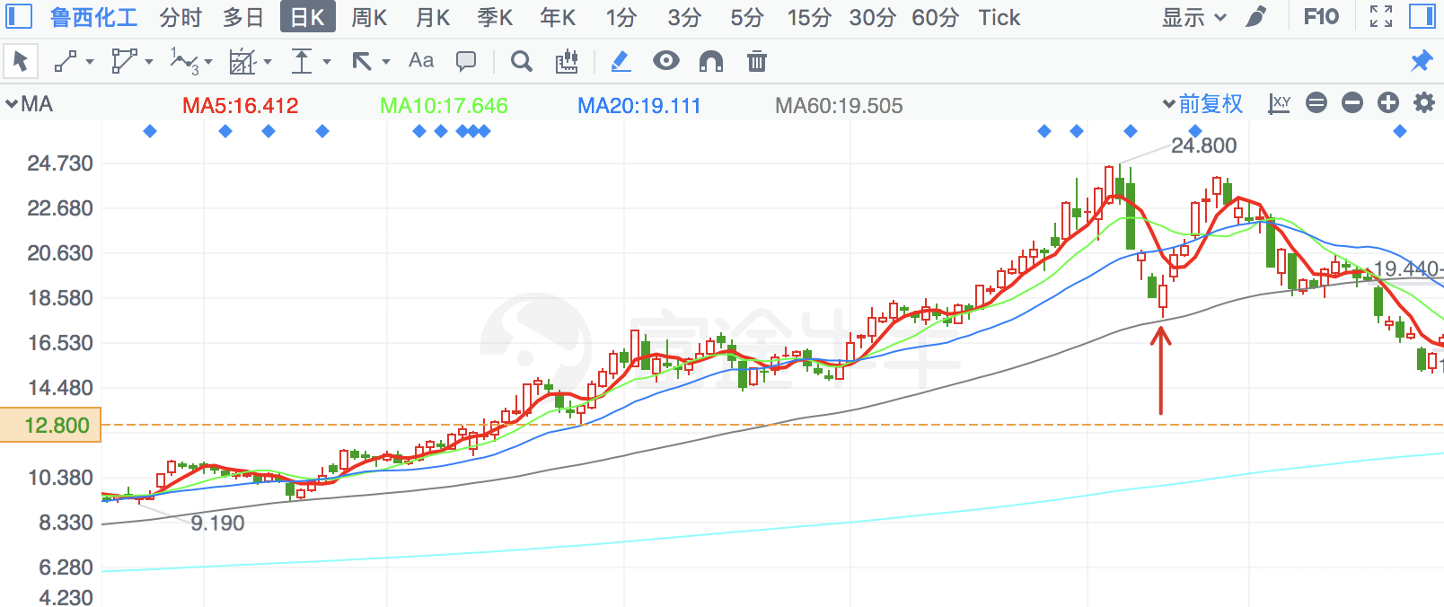

|  |  |  |
| --- | --- | --- |
| **2018/5/28** | **2691** | **冀凯股份** |

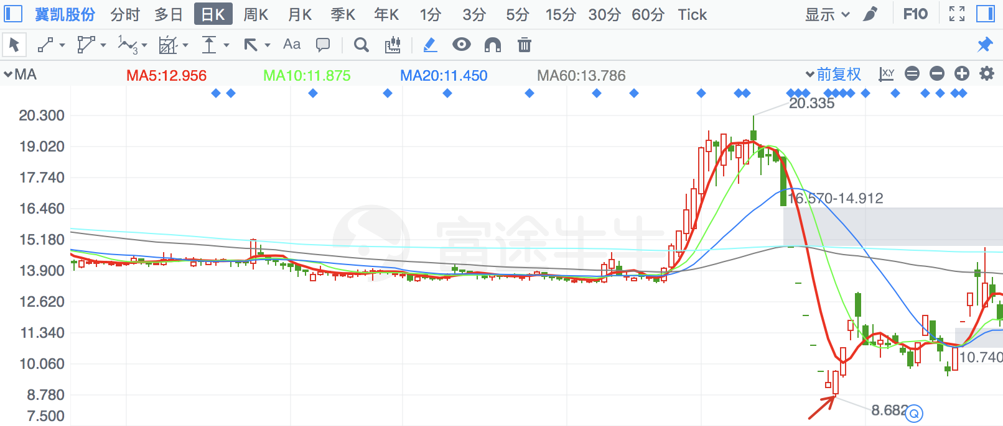

|  |  |  |
| --- | --- | --- |
| **2018/4/9** | **2873** | **新天药业** |

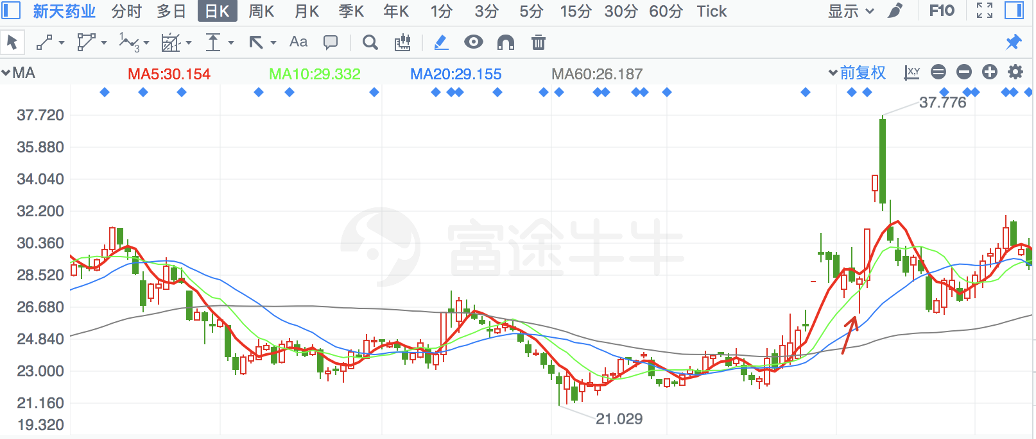

|  |  |  |
| --- | --- | --- |
| **2018/8/7** | **300630** | **普利制药** |

金针探底

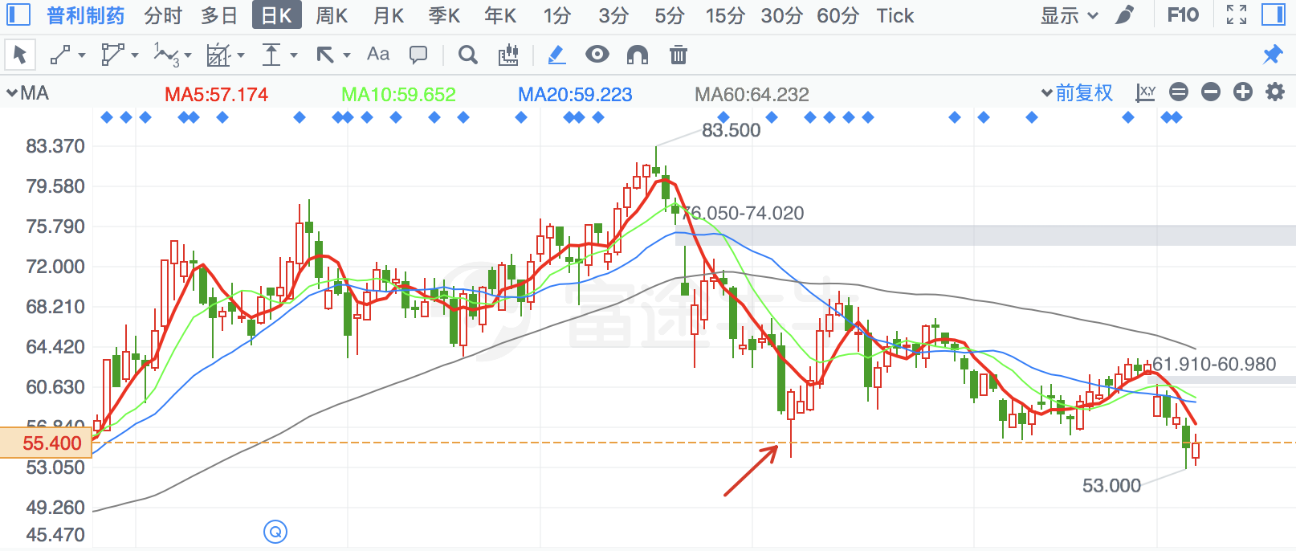

|  |  |  |
| --- | --- | --- |
| **2018/7/5** | **601990** | **南京证券** |

次新股新低

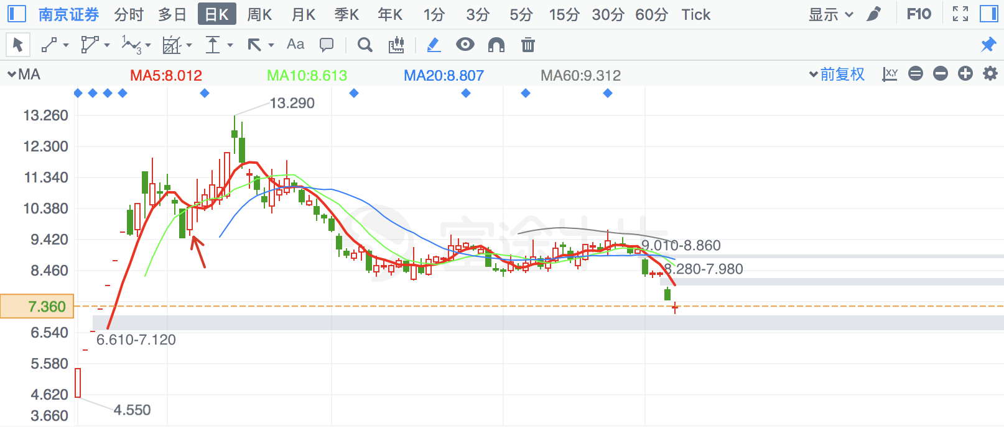

|  |  |  |
| --- | --- | --- |
| **2018/3/23** | **300672** | **国科微** |

倒锤子线

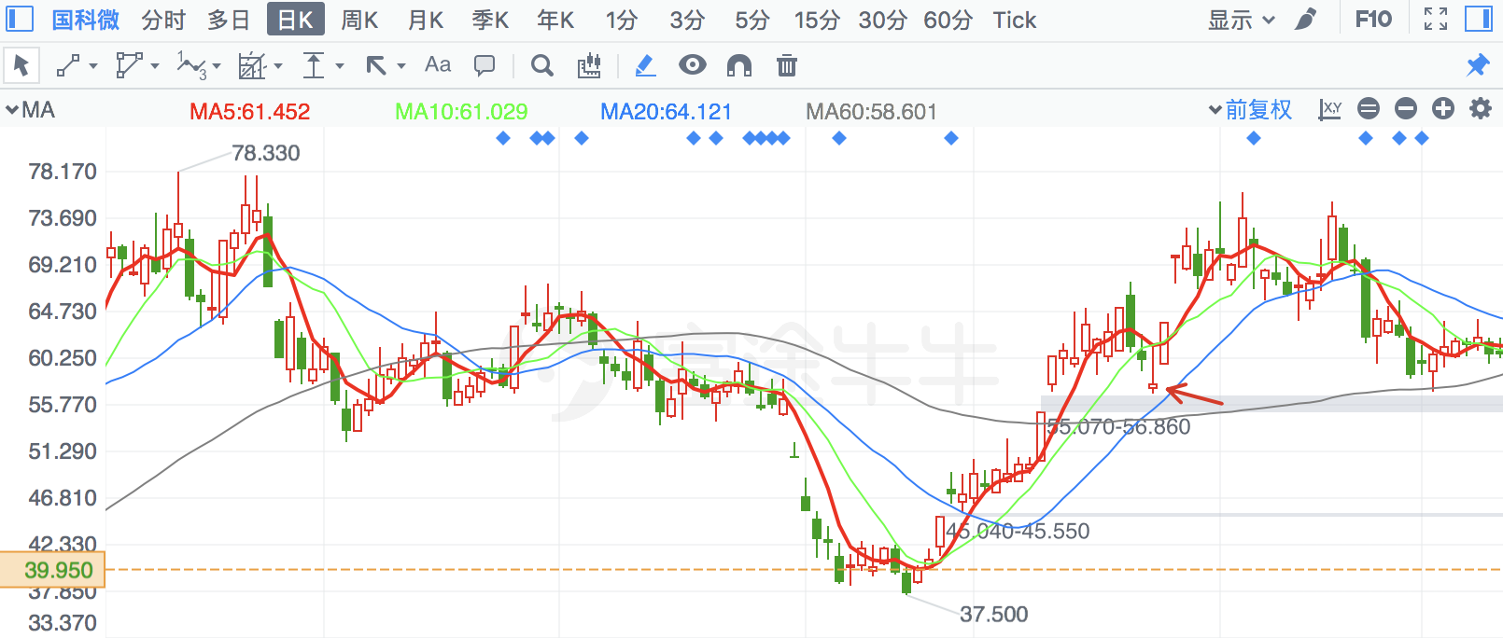

|  |  |  |
| --- | --- | --- |
| **2018/1/15** | **2915** | **中欣氟材** |

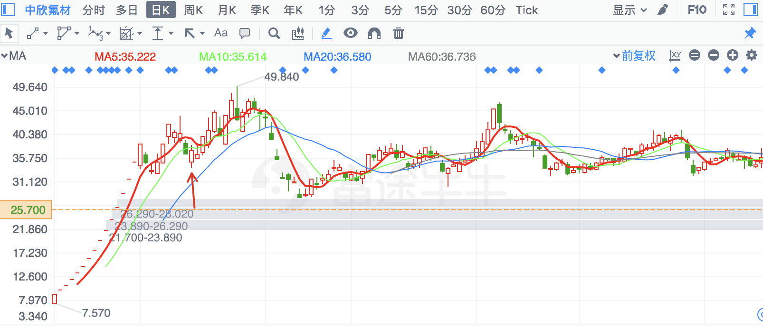

|  |  |  |
| --- | --- | --- |
| **2018/4/11** | **735** | **罗牛山** |

月线、季线支撑

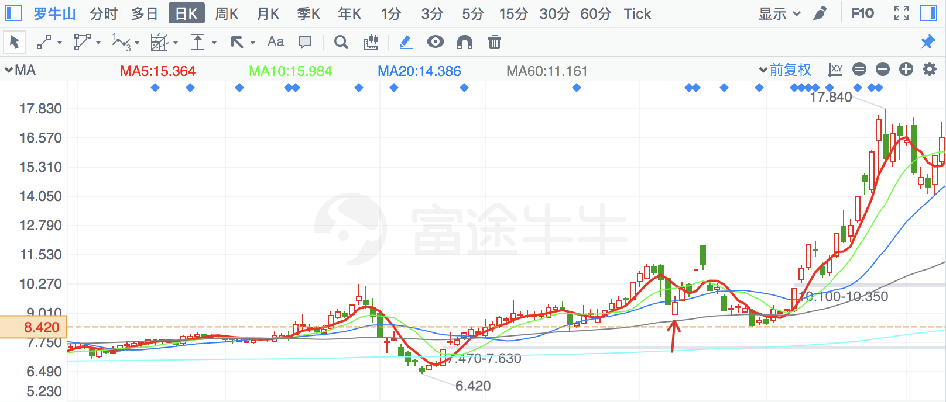

|  |  |  |
| --- | --- | --- |
| **2018/4/18** | **300657** | **弘信电子** |

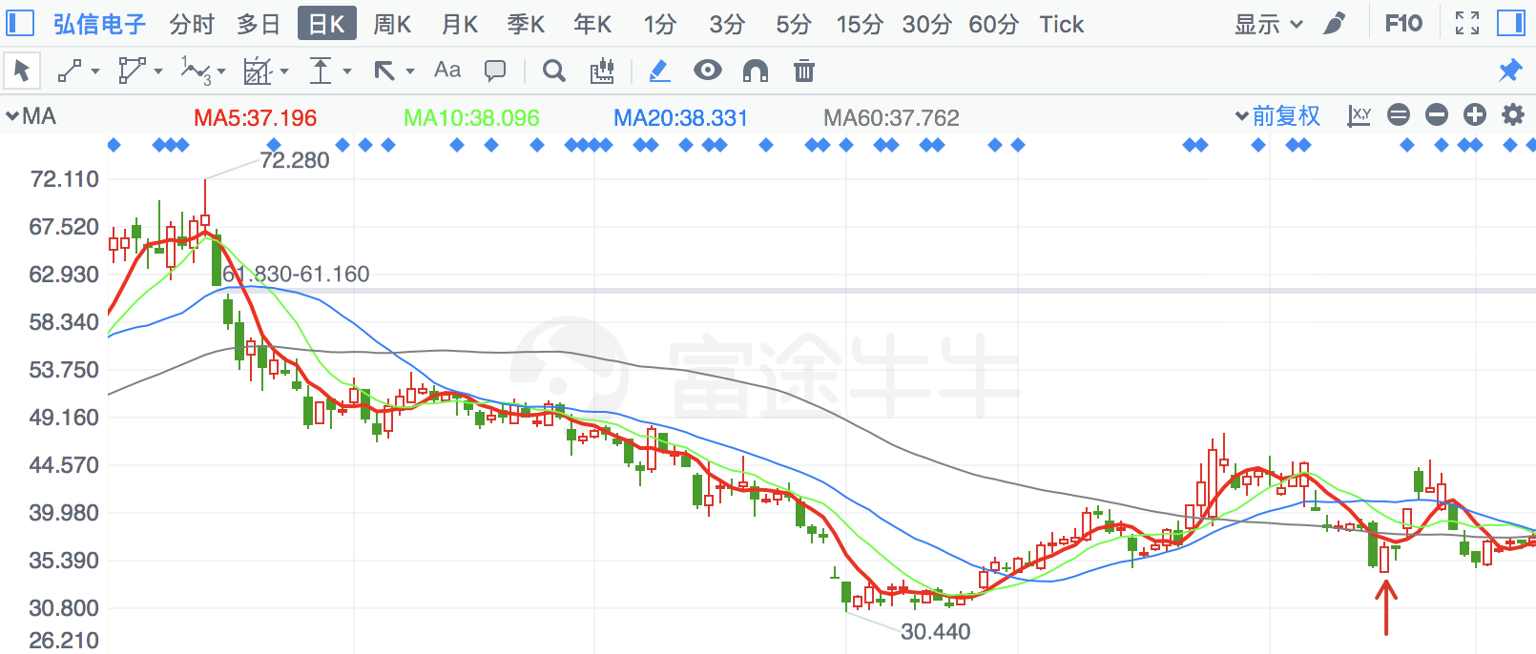

|  |  |  |
| --- | --- | --- |
| **2018/1/24** | **300612** | **宣亚国际** |

月线支撑

